**Yields of the r-process in neutron star merger ejecta and its sensitivity to nuclear mass model choice**

V.V. Negrebetskiy1, K.A. Stopani2

*1Lomonosov Moscow State University, Moscow, Russia;*

*2Skobeltsyn Institute of Nuclear Physics, Moscow, Russia*

E-mail: negrebetckii.vv16@physics.msu.ru

The astrophysical r-process of nucleosynthesis is widely considered to explain the production of major amount of nuclei beyond the iron peak. This nucleosynthesis mechanism poses great interest to both astrophysics and nuclear physics. Taking place at temperatures above 1 GK and very high densities, it is believed to occur in extreme astrophysical scenarios, such as neutron star mergers and supernova blasts. Thus the main approach in r-process study is computer simulation.

Nuclei that take part in r-process reaction chains are exotic due to high neutron excess. To get their characteristics required by nucleosynthesis simulations theoretical nuclear models are used. We study the impact of the nuclear mass model choice on the results of r-process calculation. Using three different theoretical mass tables [1,2,3] we have created three libraries of astrophysical nuclear reactions based on REACLIB [4] database. We used them to simulate r-process in neutron star merger dynamical ejecta with the help of the SkyNet [5] library. Obtained results show how our r-process simulation responds to the mass model variation.

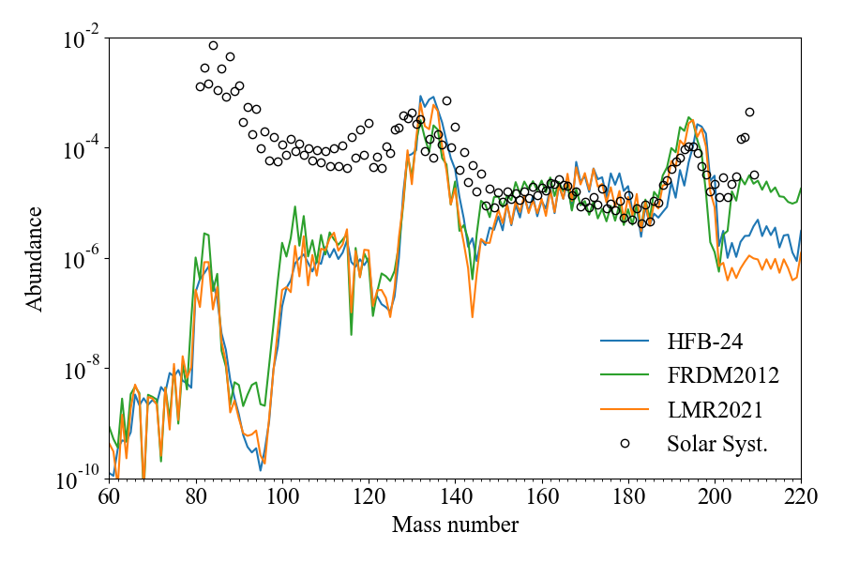

*Fig. 1. Theoretical r-process yields, calculated with different nuclear mass models, compared to experimental nuclei abundances in the Solar System.*

1. P. Möller et al, ADNDT 109, 1 (2016).

2. S. Goriely, N. Chamel, J.M. Pearson, Phys. Rev. C 88, 024308 (2013).

3. Е.В. Владимирова и др., Изв. РАН. Серия Физическая 4, 571 (2022).

4. R.H. Cyburt et al, ApJ 189, 240 (2010).

5. J. Lippuner, L.F. Roberts, ApJS 233, 18 (2017).