**Coupling Corrosion- and Pressure-Assisted Stress Buildup within the Zirconium in PWR Pipes**

A. Aryanfar1, W. A. Goddard III2

*1American University of Beirut, Riad El Solh, Beirut , Lebanon 1107*

*2 California Institute of Technology, Pasadena, CA 91125*

E-mail: [aryanfar@caltech.edu](mailto:aryanfar@caltech.edu)

The corrosion in the pipelines of pressurized water reactor is a catastrophic event, leading to the ultimate fracture and failure [1,2,3]. Herein, we develop a real-time framework for the accumulation of compressive stresses via coupling corrosion-induced and the internal/external fluid pressure, where the former causes the irreversible (plastic) deformation the latter leads to the reversible (elastic) compression. In this regard, we quantify the real-time infiltration of the oxygen within the metal matrix in the curved boundary, leading to the augmentation in the volume [4] and we compute stoichiometrically the resulted equivalent oxide thickness. Subsequently, we compute the accumulated compressive stress in real time from both elastic and plastic events, which could be used as a measure for anticipation of the onset of mechanical failure. The developed analytical framework could be utilized for quantifying the design parameters for safe operation of the transport pipes, particularly in applications related to the high-pressure and highly corrosive environments.

**Keywords:** Corrosion Stress, Elastic Stress, Curved Boundary, Inner/Outer Corrosion, Mechanical Failure.

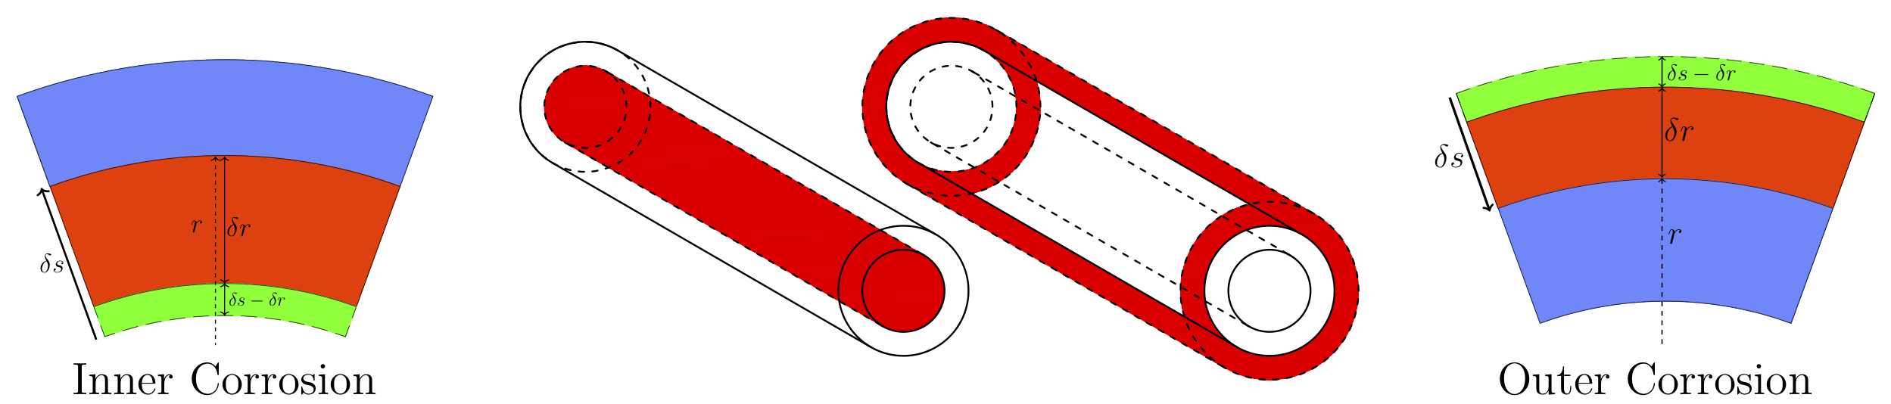

*Fig. 1. Logo of the Nucleus-2022 conference.*

1. John Christopher Scully. The fundamentals of corrosion. 2. 1978.

2. AS Zaimovskii. Zirconium alloys in nuclear power. Soviet Atomic Energy, 45(6):1165–1168, 1978.

3. Rion A Causey, Donald F Cowgill, and Robert H Nilson. Review of the oxidation rate of zirconium  alloys. Report, Sandia National Laboratories, 2005.

4. B Cox. Some thoughts on the mechanisms of in-reactor corrosion of zirconium alloys. J. Nucl. Mater., 336(2):331–368, 2005.