**Nucleon transfer processes in low-energy reactions with helium isotopes**

M. A. Naumenko1, V. V. Samarin1,2, Yu. E. Penionzhkevich1,3, N. K. Skobelev1

*1 Flerov Laboratory of Nuclear Reactions, Joint Institute for Nuclear Research, Dubna, Russia; 2 Department of Nuclear Physics, Dubna State University, Dubna, Russia; 3 Department of Experimental Methods in Nuclear Physics, National Research Nuclear University, Moscow, Russia*

E-mail: anaumenko@jinr.ru

Experimental cross sections for formation of isotopes 44,46Sc and 45Ti in reactions 3,4,6He + 45Sc, 196,198Au in reactions 3,4,6,8He + 197Au, and 194Au in reaction 3He + 194Pt have been analyzed. To calculate nucleon transfer probabilities and cross sections, the time-dependent Schrödinger equation for nucleons of 3,4,6He, 45Sc, 197Au, and 194Pt has been solved numerically with a special choice of the shell model mean field for 3,4,6,8He nuclei [1] (Fig. 1). Fusion-evaporation channels were taken into account using the code of the NRV web knowledge base [2]. It was shown that the contribution of fusion-evaporation to the experimental data is significant for reactions 3,4,6He + 45Sc, whereas in the case of reactions 3,4,6,8He + 197Au and 3He + 194Pt, it is negligible. The results of calculation (Fig. 2) are in good agreement with experimental data [3, 4].

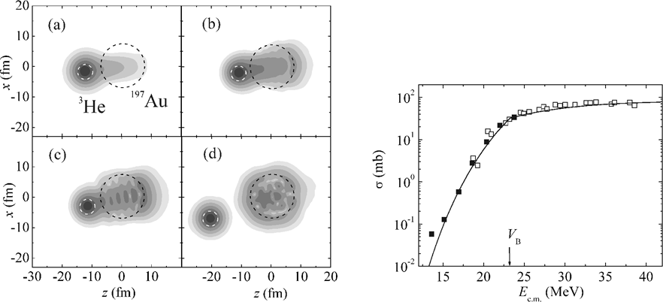

|  |  |
| --- | --- |
| *Fig. 1. Examples of time evolution of the probability density for the neutron of 3He in the collision 3He + 197Au at E*c.m*.= 20 MeV and impact parameter b = 1 fm. The course of time corresponds to panel locations (a), (b), (c), (d).* | *Fig. 2. Cross sections for formation of the isotope 198Au in the reaction 3He + 197Au: experimental data [2] (filled squares) and [3] (empty squares) along with the results of calculations. The arrow indicates the position of the Coulomb barrier.* |

1. M.A. Naumenko, V.V. Samarin, Yu.E. Penionzhkevich, and N.K. Skobelev, Bull. Russ. Acad. Sci.: Phys. 81, 710 (2017).

2. NRV web knowledge base on low-energy nuclear physics, http://nrv.jinr.ru/nrv/.

3. N.K. Skobelev, Yu.E. Penionzhkevich, E.I. Voskoboinik *et al.*, Phys. Part. Nucl. Lett. 11, 114 (2014).

4. Y. Nagame, K. Sueki, S. Baba, and H. Nakahara, Phys. Rev. C 41, 889 (1990).