**THE MODEL FOR DESCRIBING THE WIDTH OF DOUBLE GAMMA DECAY OF THE QUADRUPOLE STATE OF SPHERICAL NUCLEI**

A. P. Severyukhin1

*1Bogoliubov Laboratory of Theoretical Physics, JINR, Dubna, Russia*

E-mail: sever@theor.jinr.ru

To describe the γγ-decay, a formalism relates the electromagnetic interaction up to second order in the electromagnetic operators and two-quantum processes in atomic nuclei. In Ref.[1], the γγ-decay of a nuclear transition in competition with an allowed γ-decay has been discovered. This is the observation of the γγ-decay of the first excited Jπ=11/2- state of 137Ba directly competing with an allowed γ-decay to the Jπ=3/2+ ground state. The branching ratio of the competitive γγ-decay of the 11/2- isomer of the odd-even nucleus 137Ba to the ground state relative to its single γ-decay was determined to be (2.05±0.37)×10-6. This discovery has very recently been confirmed and the data were made more precise, in particular with respect to the contributing multipolarities [2].

This paper reports on the situation, in which the γγ-decay of the low-energy quadrupole state of the even-even nucleus occurs in a nuclear transition which could proceed by a single γ-decay in competition. The coupling between one-, two- and three- phonon terms in the wave functions of excited nuclear states is taken into account within the microscopic model based on the Skyrme energy density functional.

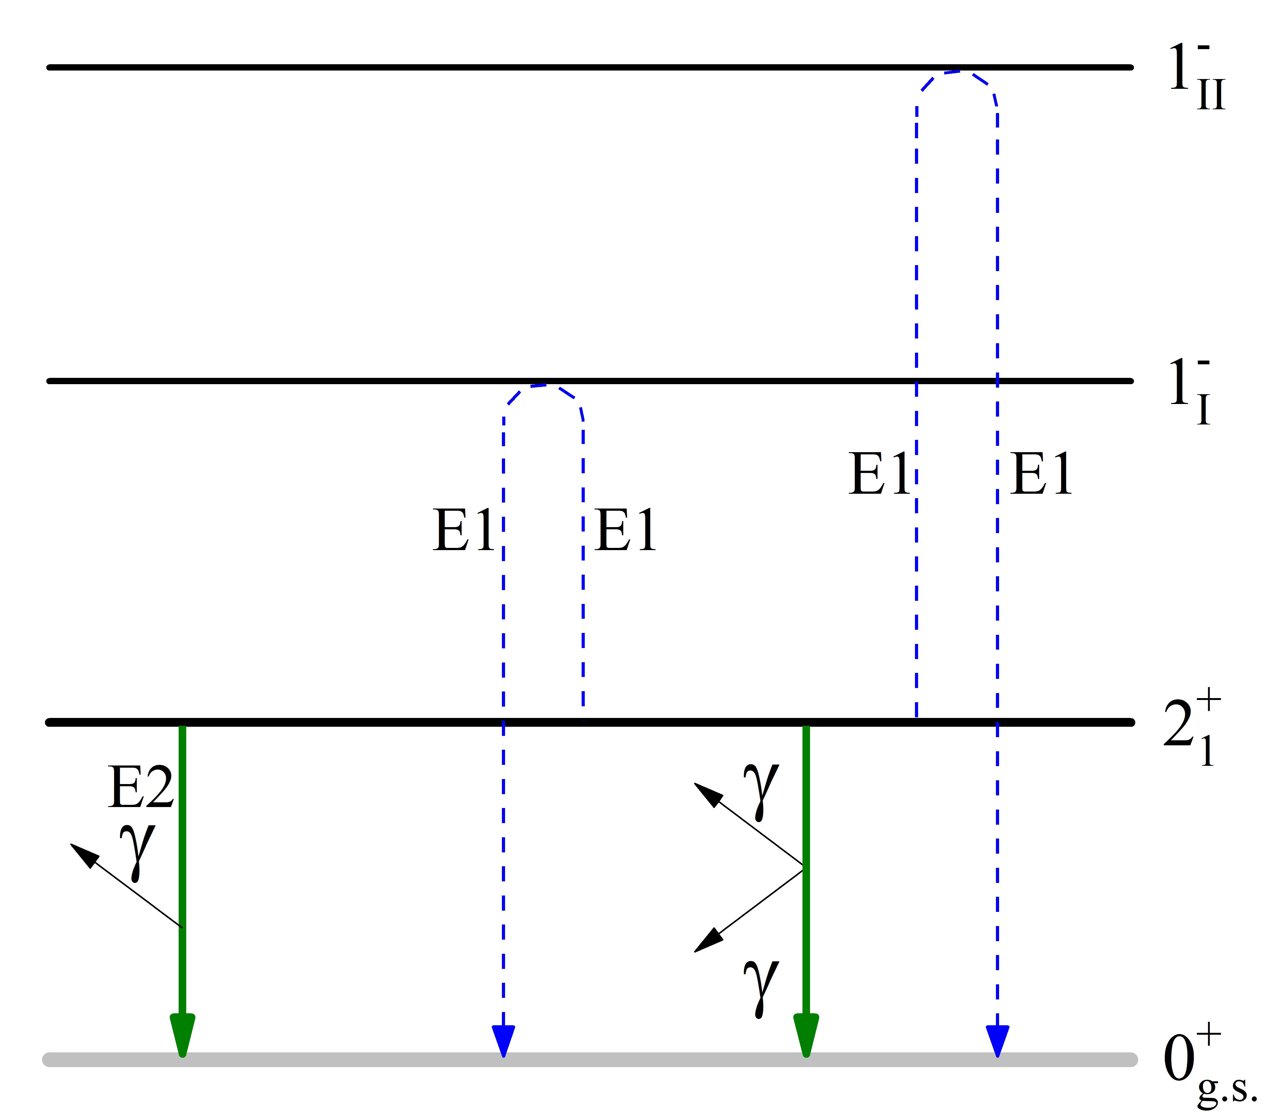

*Fig. 1. Scheme for estimating the width of nuclear double γ-decay. The dashed lines correspond to the virtual transitions.*

It is shown that the γγ-decay width is sensitive to the interaction between one- and two-phonon configurations in the giant dipole resonance region [3]. The maximal branching ratio of the competitive γγ-decay relative to its single γ-decay is predicted for 48Ca as 3×10-8. This prediction can be tested experimentally.

1. C.Walz et al., Nature. 526, 406 (2015).

2. P.-A. Söderström et al., Nature Commun. 11, 3242 (2020).

3. A.P. Severyukhin, N.N. Arsenyev, N. Pietralla, Phys. Rev. C. 104, 024310 (2021).