**CROSSING ROTATIONAL BANDS IN SUPERHEAVY EVEN-EVEN NUCLEI**

A. D. Efimov1,2, I. N. Izosimov3

*1Admiral Makarov State University of Maritime and Inland Shipping, St.-Petersburg, Russia; 2 Ioffe Physical-Technical Institute, Russian Academy of Sciences, St.-Petersburg, Russia; 3 Joint Institute for Nuclear Research, Dubna, Russia*

E-mail: efimov98@mail.ru

Foreven-even nuclei, with the exception of the only, in yrast bands there is no manifestation of the reverse bending of the moment of inertia from the square of rotation frequency (back-bending). This leads to the possibility of reproducing the level energies of yrast bands up to spins values  in the framework of the IBM1 phenomenology [1]. In present report the structure of the yrast band states was calculated within the framework of the microscopic version of IBM1 [2,3], where bosons with large spins up to  were used. The calculation was carried out for, since only for it the values of  were measured up to high spins. The mapping of phonons to bosons is carried out bythe traditional way. The wave functions in the boson representation have the form  where  are wave functions containing a superposition of -bosons only. Moreover, the collectivization is so strong that the number of quadrupole bosons  in ****for the ground state. The Hamiltonian is taken in the form  where  is the IBM1 Hamiltonian with parameters obtained from -phonons and taking into account renormalizations due to , non-collective phonons, − energies of -bosons.  The parameters that determine the boson operators are calculated based on the microscopic procedure. This leads to precise reproduction of energies up to spin  with an error not exceeding a few keV. As can be seen from the presented figure, the reproduction of the  values by using the IBM1 phenomenology [1] corresponds to the experiment. The composition of the wave functions is presented in the following figure and it shows a smooth replacement of the collective component, built only from -bosons, by components that include high-spin pairs or -bosons with momentums  Such smooth replacement explains the absence of the back-bending and the smooth dependence of  on spin.

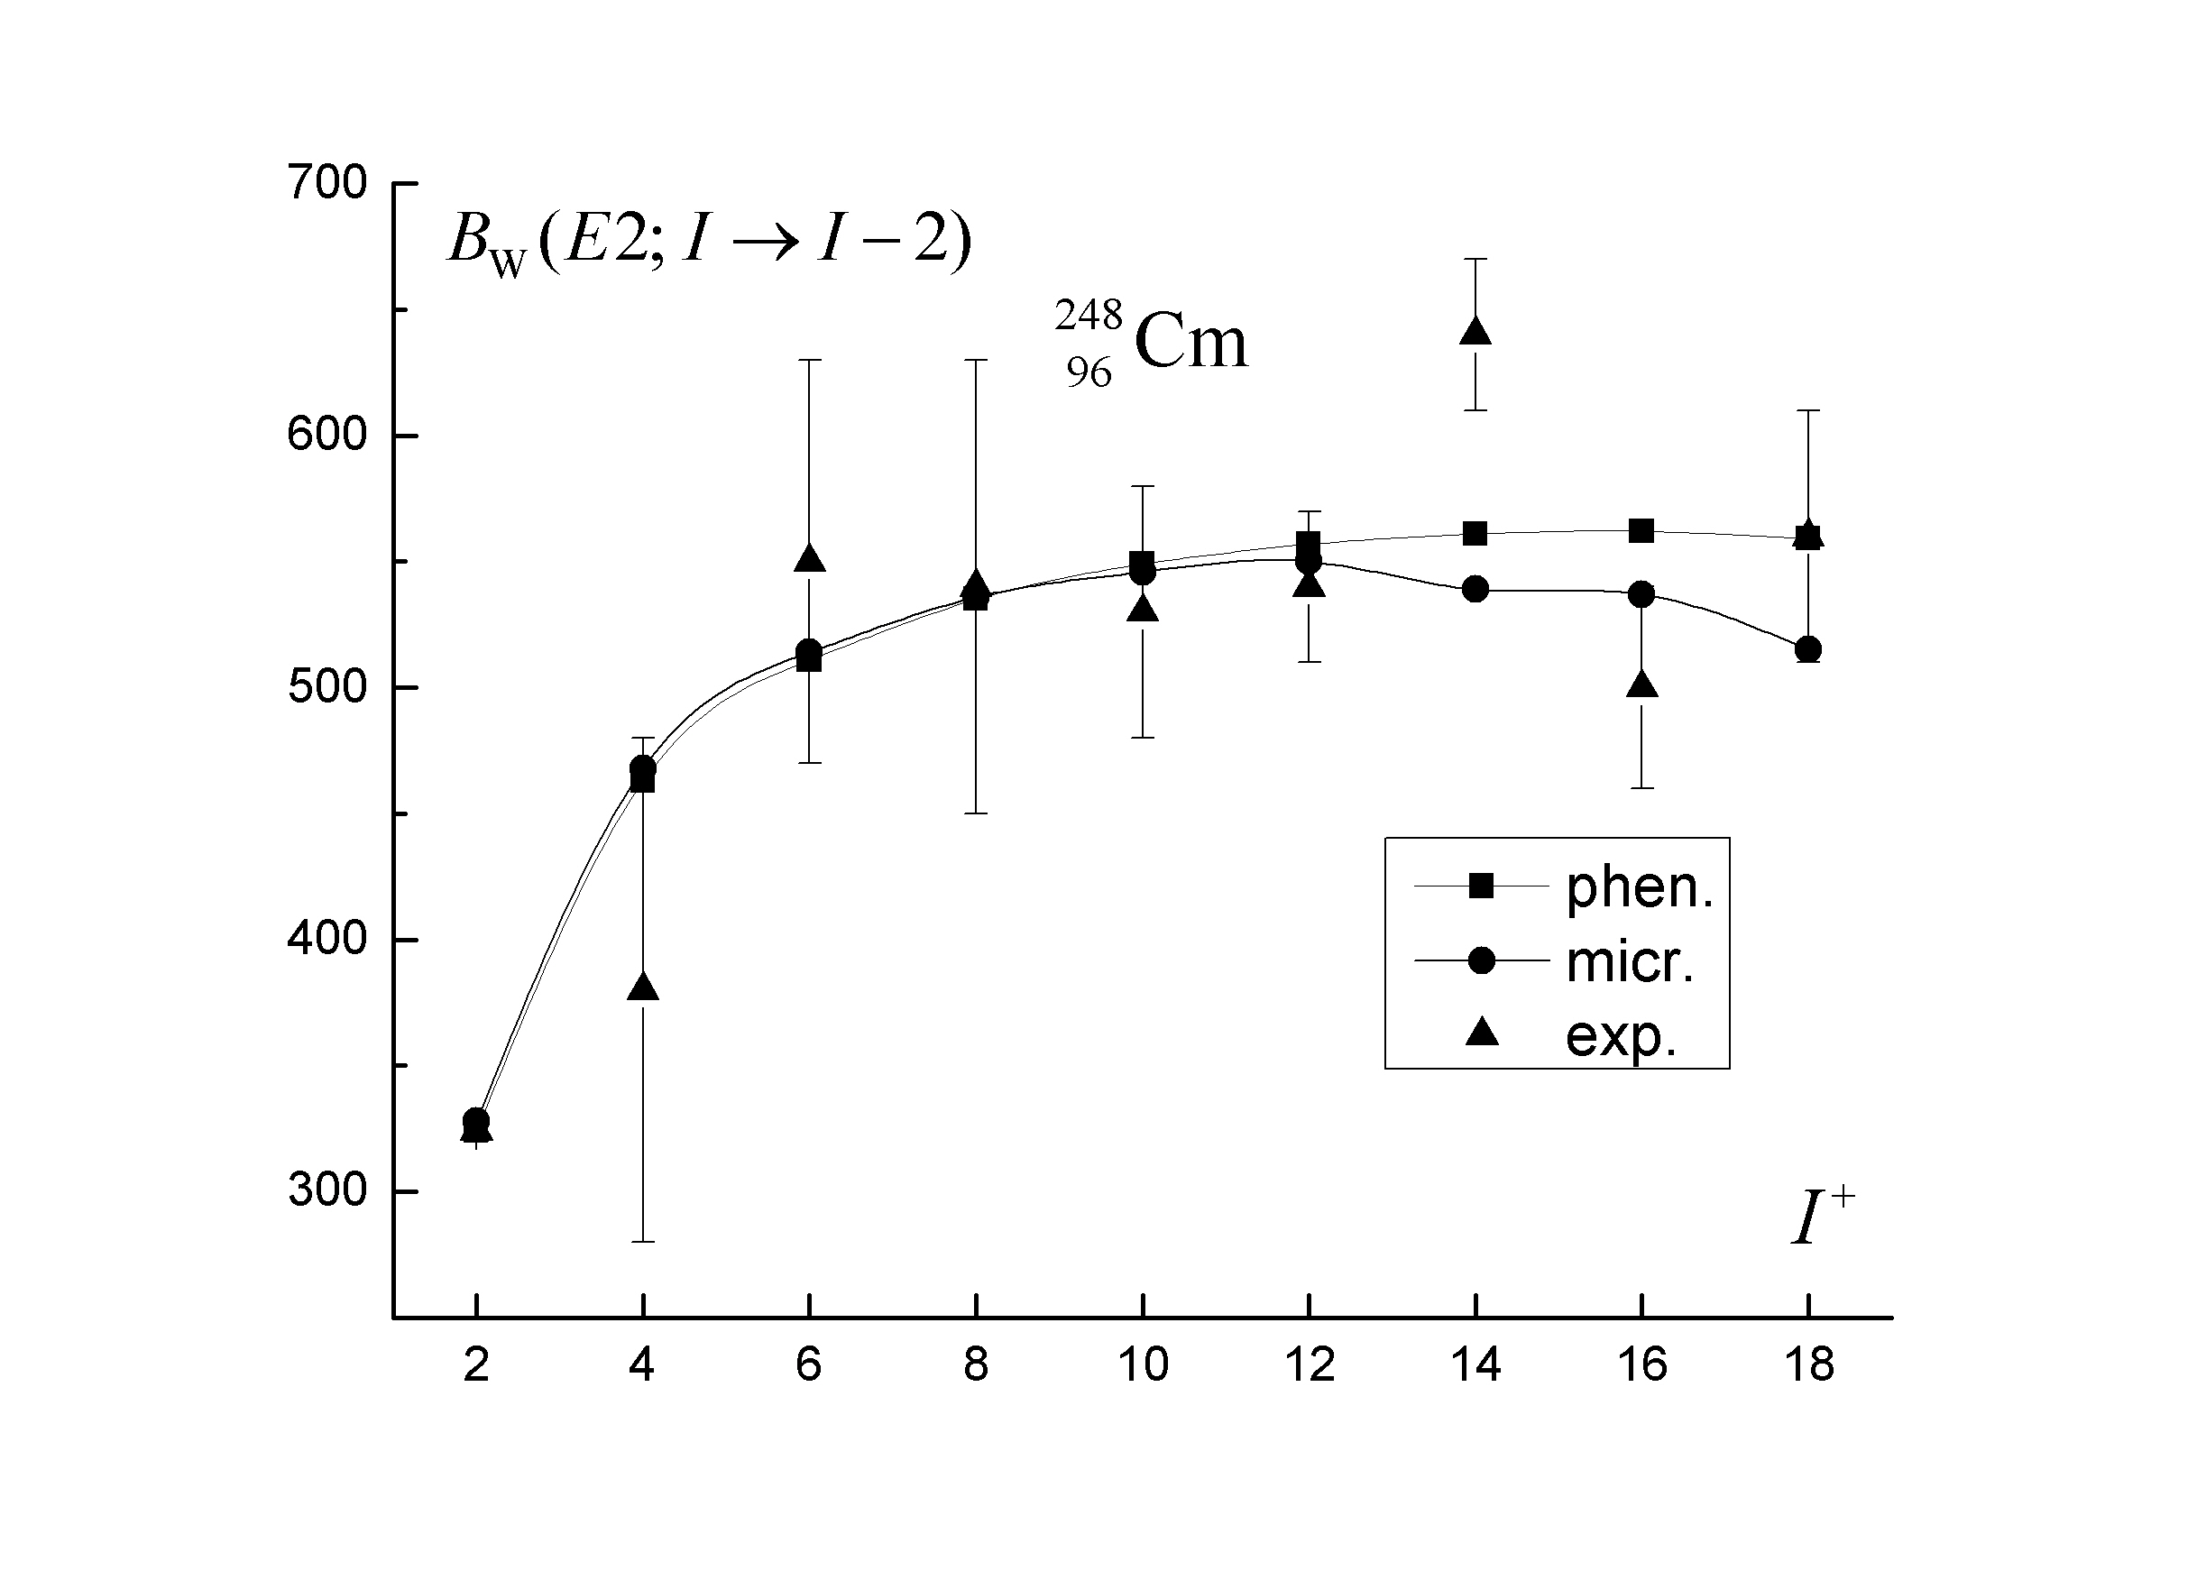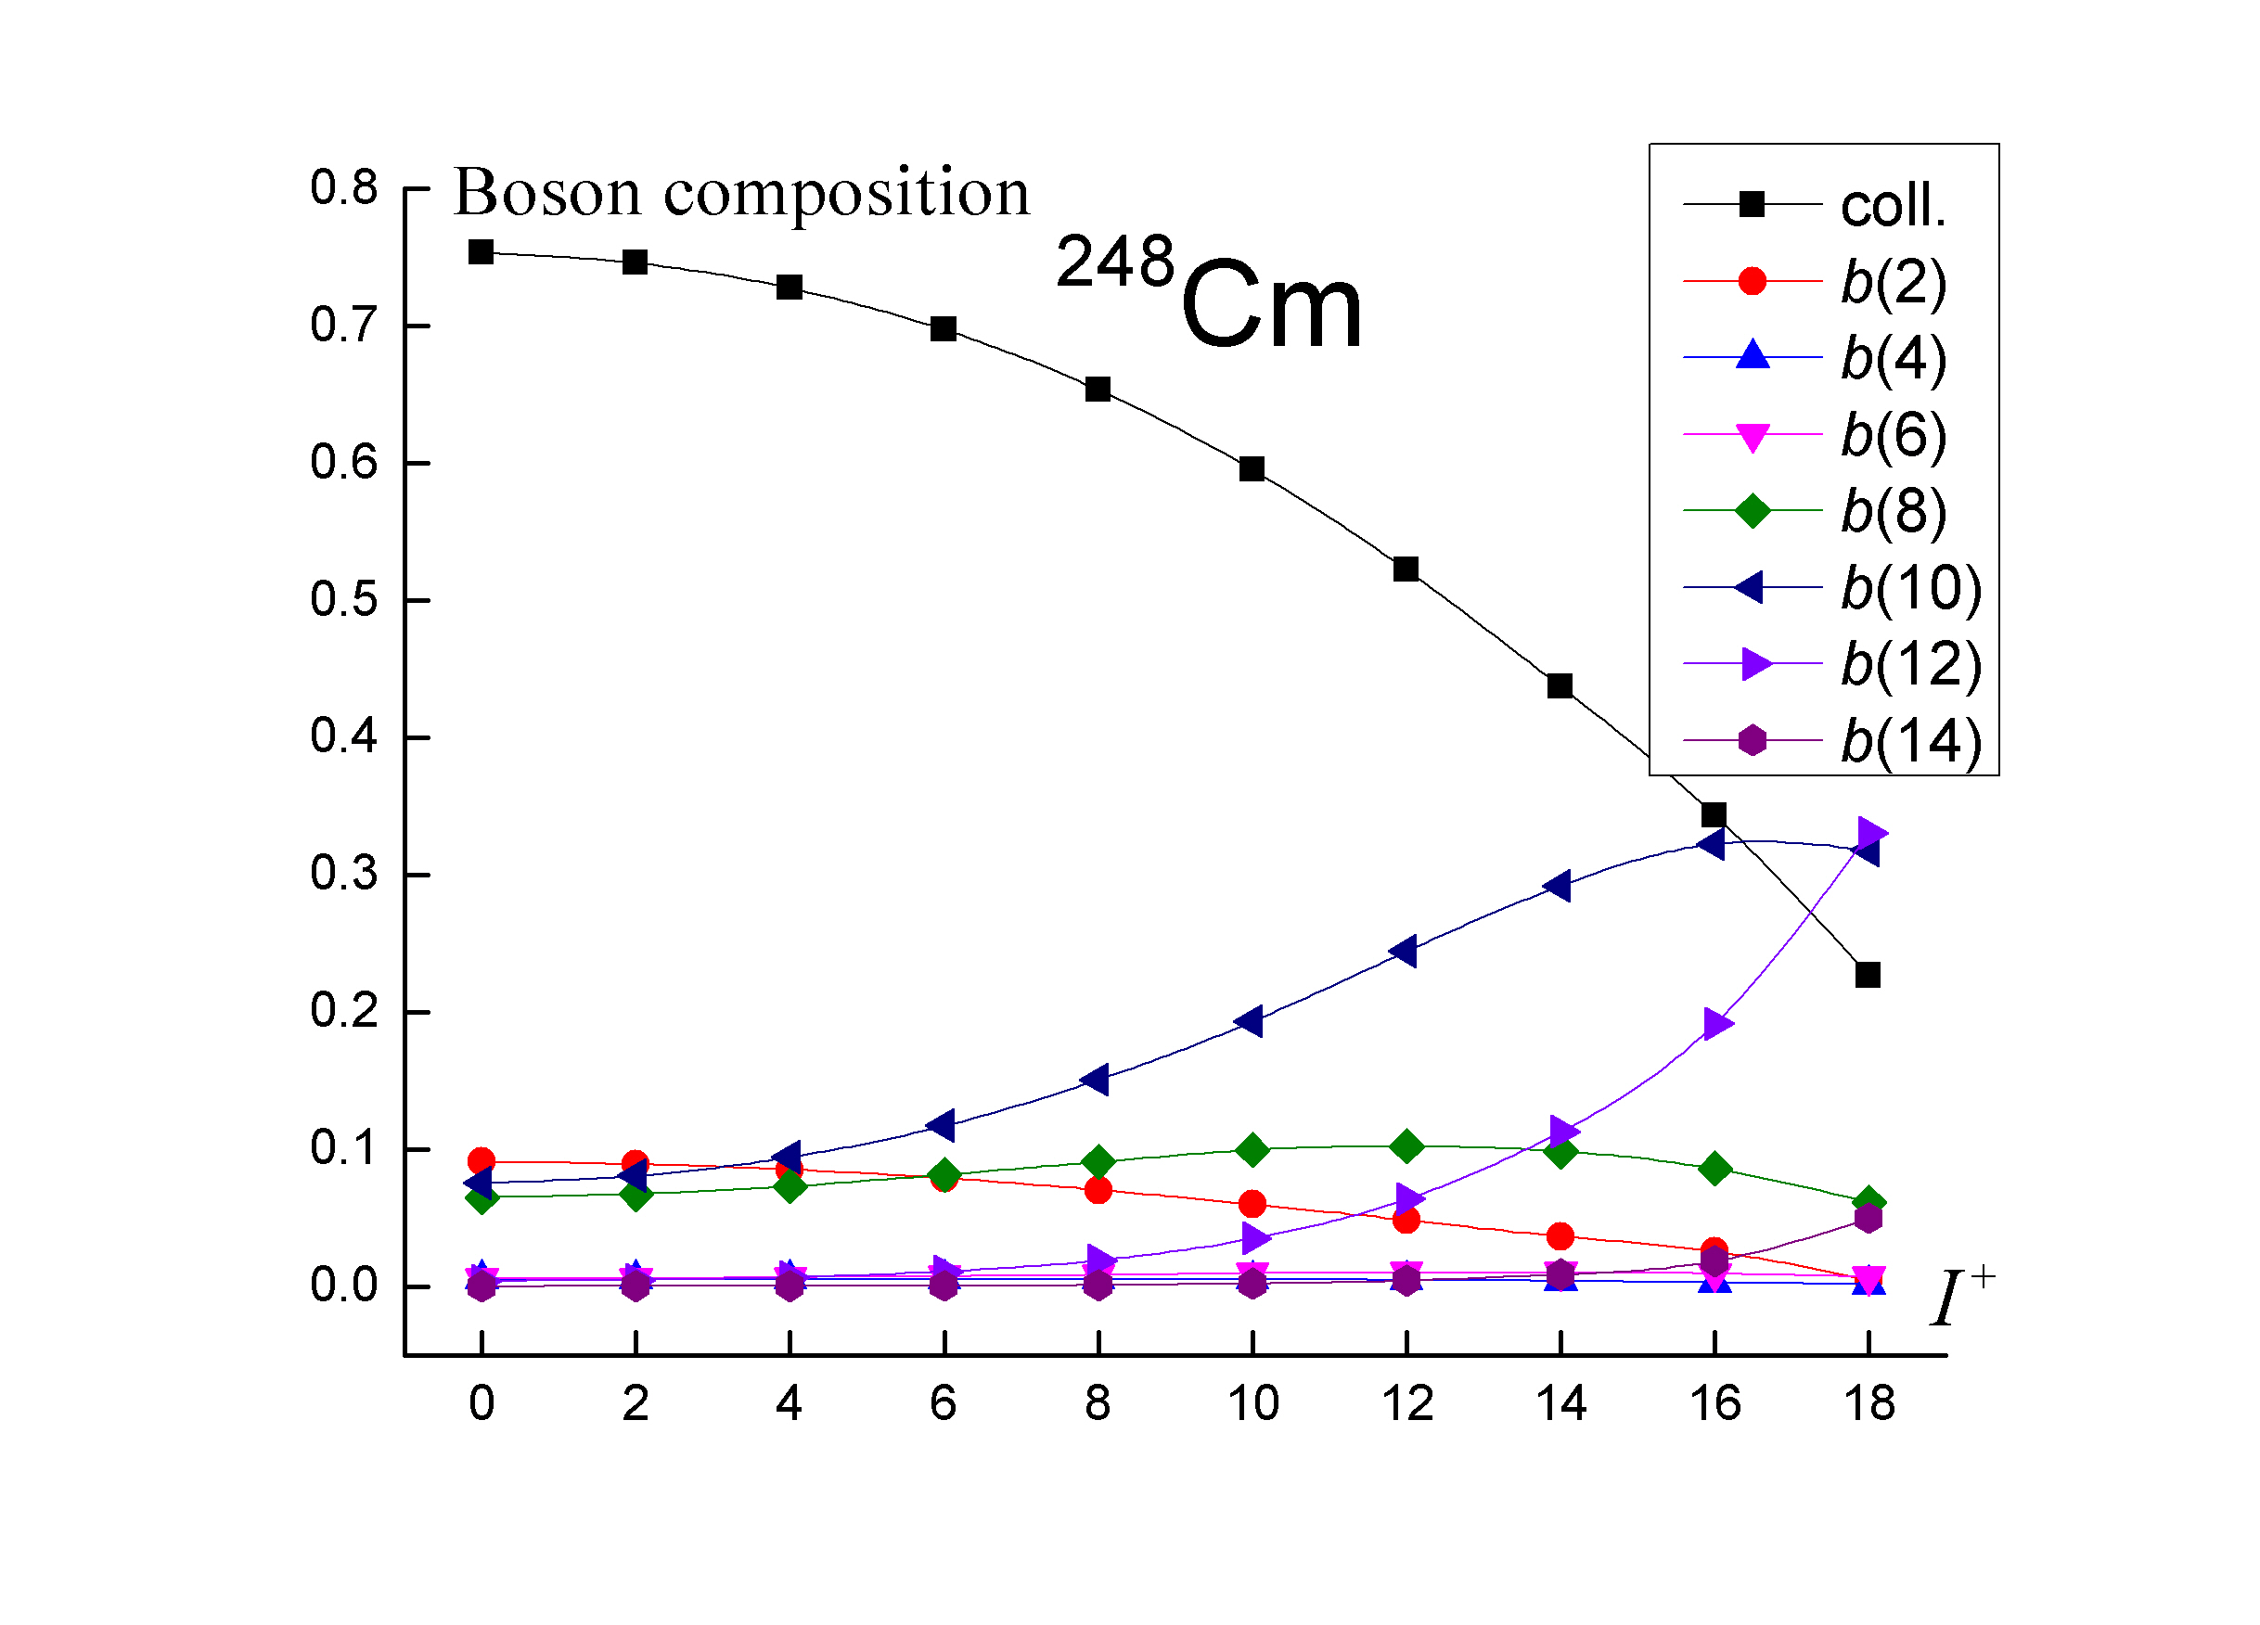

1. A. D. Efimov, I. N. Izosimov, Phys. At. Nucl. 84, 660 (2021).

2. A. D. Efimov, V. M. Mikhajlov, Bull. Russ. Acad. Sci. Phys. 82, 1266 (2018).

3. A. D. Efimov, Rus. J. Nucl. Phys. 83, 380 (2020).