**COMPTON DESINTEGRATION OF POSITRONIUM**

Yu. V. Popov1,2, I.S. Stepantsov3, I.P. Volobuev1

*1SINP, Lomonosov Moscow State University, Moscow, Russia; 2BLTP, Joint Institute of Nuclear Research, Dubna, Russia; Some Other Institute, Location, State; 3Physics Faculty, Lomonosov Moscow State University, Moscow, Russia*

E-mail: popov@srd.sinp.msu.ru

The recent experiments on Compton scattering using a new experimental technique [1] gave rise to a new wave of interest in this old effect discovered 100 years ago. To describe the process of Compton decay of positronium we use the nonrelativistic *A*2 approximation.

We study the Compton single ionization of positronium in comparison with the same of hydrogen [2]. The initial photon energy of a few keV allows one to apply the non-relativistic approach. Interesting differences in the behavior of various differential cross sections of the process are observed. In particular, the conditions were found, under which the electron and positron move parallel to each other with equal velocities, which leads to a series of resonances (see Fig.1). This suggests that the probability of annihilation is suppressed in this continuum state, and it is likely to be a long-lived one, especially in the presence of external electric and magnetic fields.

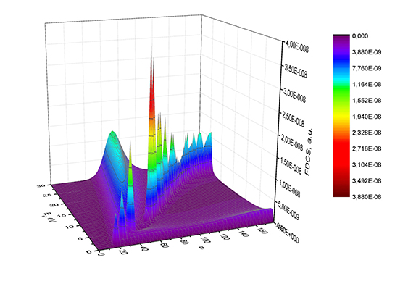

*Fig. 1. FDCS (atomic units) of Compton positronium decay versus the energy Ee(eV) of the emitted electron and the photon scattering angle θ. The photon energy is ω = 5 keV*

1. M. Kircher *et al.* Nature Physics16(4), 756 (2020) 2. S. Houamer *et al.* EPJD74, 81 (2020)