STUDY OF THE ¹⁶O(α, α)¹⁶O(3–) AND ¹⁵N(α, t)¹⁶O(3–)
REACTIONS MECHANISM AT E_{α} = 30.3 MeV

L. I. Galanina, N. S. Zelenskaya, V. M. Lebedev, N.V. Orlova, A. V. Spassky
Lomonosov Moscow State University, Skobeltsyn Institute of Nuclear Physics,
Moscow, Russia
E-mail: ns-zelenskaya@yandex.ru

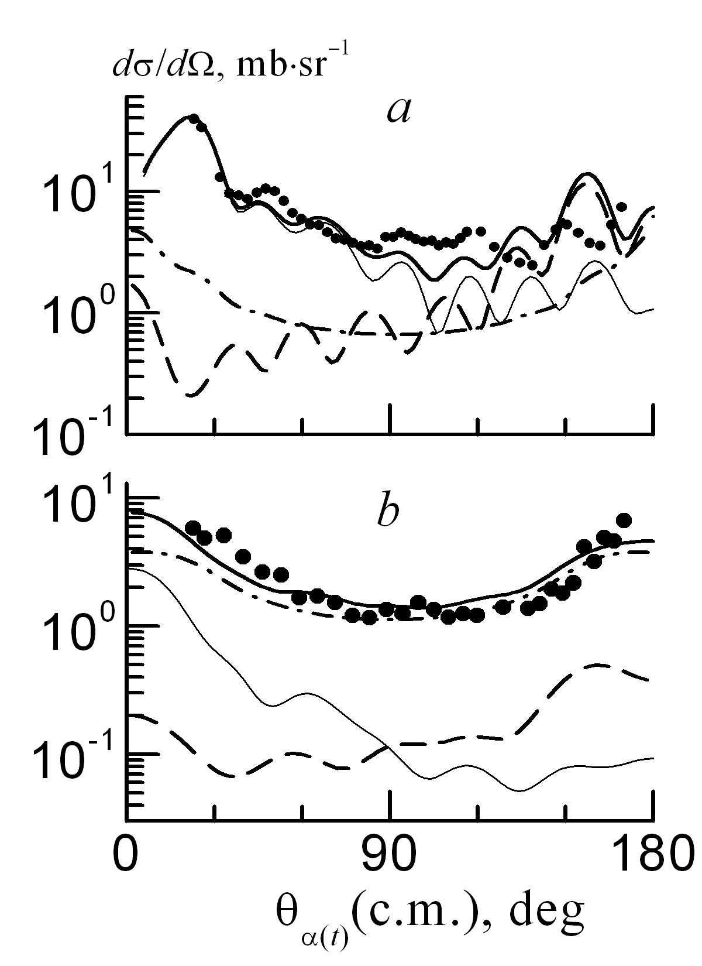
Cross sections of (α, α′) (a) and (α, t) (b) reactions: thin solid line – CC (stripping), dotted – exchange of ¹²С , dot-dash – CN, fat solid − sum, black dots – experiment
The study of the differential cross sections angular dependence of the reactions ¹⁶O(α, α′)¹⁶О(3–) [1] and ¹⁵N(α, t)¹⁶O(3–) [2] at E_{α} = 30.3 MeV was carried out. Both magnitude and shape of the measured cross sections and large value of E3 transition between the ground and 3⁻ level of ¹⁶O nucleus justify the use of CCBA formalism, when both couple channels method (CC) and DWBA are combined (FRESCO [3]) as well as the compound nucleus (CN) mechanism (TALYS [4]) in the theoretical analysis. The strength of coupling factors were introduced from the experimental reduced transition probability B(E3). The exchange of ¹²С cluster with summation over all states allowed by the selection rules for transfer mechanism at both reactions and proton stripping for the (α, t)-reaction were taking into account. The spectroscopic amplitudes are obtained in the shell model. The calculated angular distributions, together with the experimental ones, are shown in figs. It can be seen that in (α, α′)-scattering, the cross section is determined by collective excitation in the front hemisphere and by ¹²С exchange at large angles. The СN contribution is not noticeable. In the reaction (α, t), the main contribution is made by the CN mechanism, else the contribution of the proton stripping is noticeable at forward hemisphere. The ¹²C exchange mechanism is important at θ_{t} > 90°. The performed analysis showed that the calculated cross sections of both reactions agree with the experimental one without introducing normalization factors only when all considered mechanisms are taken into account.

- A.V. Ignatenko, V. M. Lebedev, N. V. Orlova, et al., Phys. Atom. Nucl. 59, 565 (1996).
- A.V. Ignatenko, V. M. Lebedev, N. V. Orlova, et al., Phys. Atom. Nucl. 61, 1 (1998).
- J. Thompson, Comp. Phys. Rep. 7, 167 (1988); http:// www.fresco.org.uk.
- J. Koning, S. Hilaire, and M. C. Duijvestijn, TALYS: AIP Conf. Proc. 769, 1154 (2005).

