**DEVELOPMENT OF A METHOD FOR MONITORING THE ABSORBED DOSE IN PHOTON RADIATION THERAPY**

A.G. Sinelnikov1, A.P. Chernyaev1, A.A. Shcherbakov1, E.N. Lykova, S.A. Zolotov1

*1Lomonosov Moscow State University, Moscow, Russia;*

E-mail: Sinelnikov1995@gmail.com

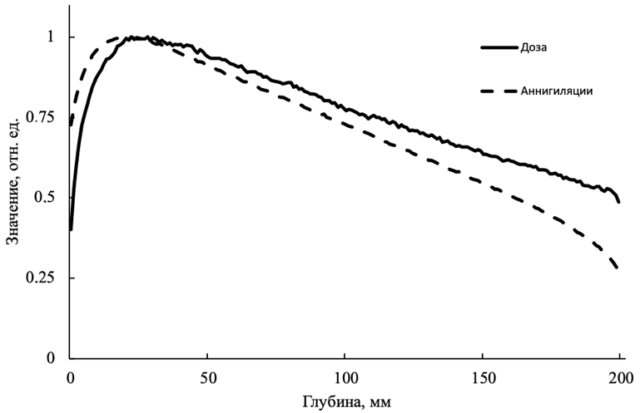New results of a study aimed at developing a method for upgrading existing medical electron accelerators, which can become a real-time method for assessing the dose distribution in the patient's body during irradiation, are presented [1,2]. The paper presents the idea of creating a mathematical model that makes it possible to estimate the distribution of the absorbed dose in the studied tissue area by the distribution of annihilation photons arising in the process of irradiation.

*Fig. 1. Depth distribution of the absorbed dose and the number of annihilation events.*

To study the proposed method, a computer experiment was performed using the GEANT4 package based on the Monte Carlo method. As part of the work performed, the correlation between the distribution of the absorbed dose of photon radiation and the distribution of positron annihilation coordinates was estimated, and the energy spectra of bremsstrahlung and annihilation photons were analyzed.

The study was supported by the Interdisciplinary Scientific and Educational School of Moscow University “Photonic and Quantum Technologies. Digital Medicine.

1. Sinelnikov A.G., Chernyaev A.P., Lykova E.N. et al., Med. Phys. 2020. №1 (85). P. 85-89
2. Синельников А.Г., Черняев А.П., Учен. зап. физ. фак-та Моск. ун-та. 2021. №4. С. 2140501.