**VORTICITY AND HELICITY FIELDS IN HEAVY-ION COLLISIONS AND HYPERON POLARIZATION**

N. T. Tsegelnik1, E. K. Kolomeitsev1,2, V. V. Voronyuk1,3

*1Joint Institute for Nuclear Research, Dubna, Russia; 2Matej Bel University, Banska Bystrica, Slovakia; 3Bogolyubov Institute for Theoretical Physics, Kiev, Ukraine*

E-mail: tsegelnik@theor.jinr.ru

The experimentally observed significant polarization of L and anti-L particle in heavy-in collisions [1] lead to speculations that rapidly rotating swirls are of nuclear matter are created [2]. We use the transport model PHSD to simulate the Au+Au and Pb+Pb collisions at NICA energies and perform the fluidization procedure determining density, temperature, and velocity fields created at different stages of the collisions. Vorticity and hydrodynamic helicity fields are calculated and visualized in dynamics. The velocity field is illustrated on the left panel in Fig.1. It looks dominantly as the Hubble-like profiles expanding in transverse and longitudinal directions (approximate cylindrical symmetry). The small vorticity field looks like a small perturbation on top of the longitudinal and transverse flows. The vorticity field is shown on the right panel of Fig.1. We see that two vortex (asymmetrical) rings moving in the opposite direction along the z-axes are formed. The PHSD model is proved to describe successfully hyperon yields in the broad range of collision energies of our interest. Therefore, we can calculate the polarization of (anti-)hyperons on a dynamic freeze-out surface. The experimental polarization of L is well reproduced. However, the anti-L polarization is underestimated.

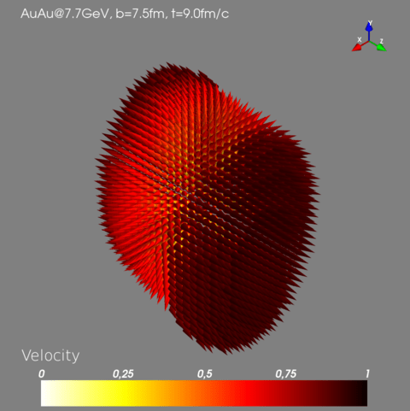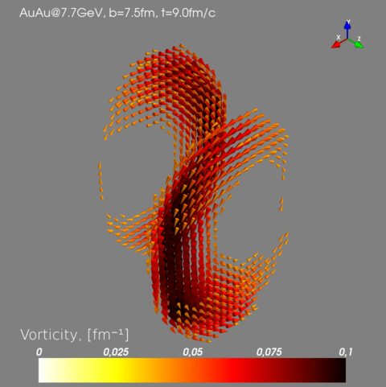

*Fig. 1. Velocity and vorticity fields calculated within PHSD model for Au+Au collisions at $\sqrt{s_{NN}}=7.7GeV$*  for impact parameter $b=7.5fm$*at the time moment*

1. L. Adamczyk et al., Nature 548, 62 (2017).

2. H. Petersen, Nature 548, 34 (2017).