**MONITORING OF PULSED INTERMEDIATE-ENERGY NUCLEON BEEMS USING AIR ACTIVATION**

V. M. Skorkin1

*1Institute for Nuclear Research, Russian Academy of Sciences, Moscow, Russia*

E-mail: [skorkin@inr.ru](mailto:skorkin@inr.ru)

Pulsed nucleon beams are used for radiation therapy at charged particle accelerators and for science material studies at ionizing radiation sources. Secondary radiation from the interaction of the beam with biological tissue and material is used to control the beam parameters and the absorbed dose [1, 2].

Proton therapy unit and pulsed neutron source have air channels for beam formation. Intermediate energy nucleons are non-elastically scattered by air atoms (nitrogen, oxygen, argon, etc.) and creates short-lived radionuclides (life tame from 20 ms to 100 s) in spallation process. Gamma and beta radiation from the decay of radionuclides can be used to pulsed nucleon beam monitoring. An activation monitoг for direct measurement of the medium energy nucleon flux was based on MKS-01R radiometer and а single-board Raspberry Pi2 microcomputer. The monitor has been tested when detecting radiation particles from activated air at the proton therapy unit and at the pulsed neutron source.

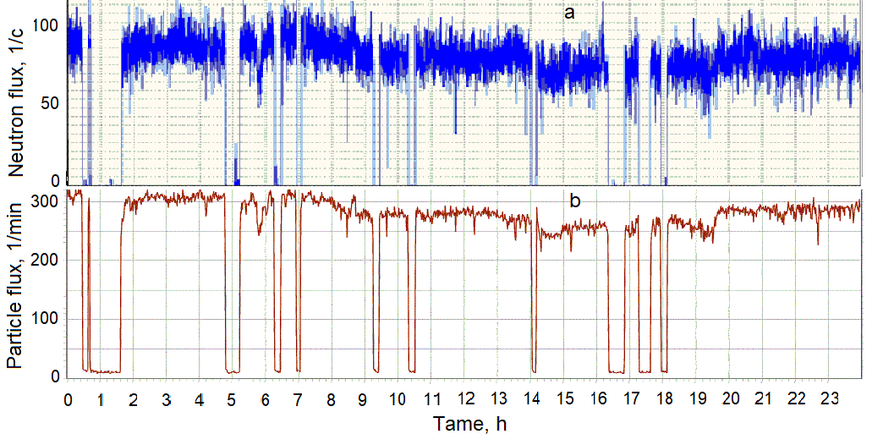

*Fig. 1. Time diagrams of the neutron beam fluxes of the pulsed neutron source (a) and the gamma and beta radiation from activated air (b).*

The absorbed dose of the proton beam in cell cultures using Gafchromic film and the pulsed neutron flux using UDBN detector were measured. The sensitivity of the monitor to neutrons estimated from these data was about 0.02 - 0.1 pulses/(n/cm2). The monitor allows to control pulsed beams of protons and neutrons with an energy of 20-200 MeV at a frequency of up to 50 Hz.

1. F. Hueso-González, M. Rabe,T. Ruggieri et al, Phys. Med. Biol. 63, 185019 (2018).

2. S. Marcatili, J. Collot, S. Curtoni et al, Phys. Med. Biol. 65, 245033 (2020).