**Resent results of the KamLAND-Zen experiment**

A. Kozlov

*National Research Nuclear University “MEPhI”, Moscow, 115409, Russia;*

E-mail: aakozlov1@mephi.ru

The KamLAND-Zen experiment provided new stringent constraints on the neutrinoless double-beta (0νββ) decay half-life in Xe-136 using a xenon-loaded liquid scintillator. Improved search was based on an upgraded detector with almost double the amount of enriched xenon and an ultra-low radioactivity container, corresponding to an exposure of 970 kg yr of Xe-136. This new data provides valuable insight into backgrounds, especially from cosmic muon spallation of xenon, and has required the use of novel background rejection techniques. We obtained a lower limit for the 0νββ decay half-life of T1/2 > 2.3 × 1026 yr at 90% C.L., corresponding to upper limits on the effective Majorana neutrino mass of 36 – 156 meV using commonly adopted nuclear matrix element calculations.

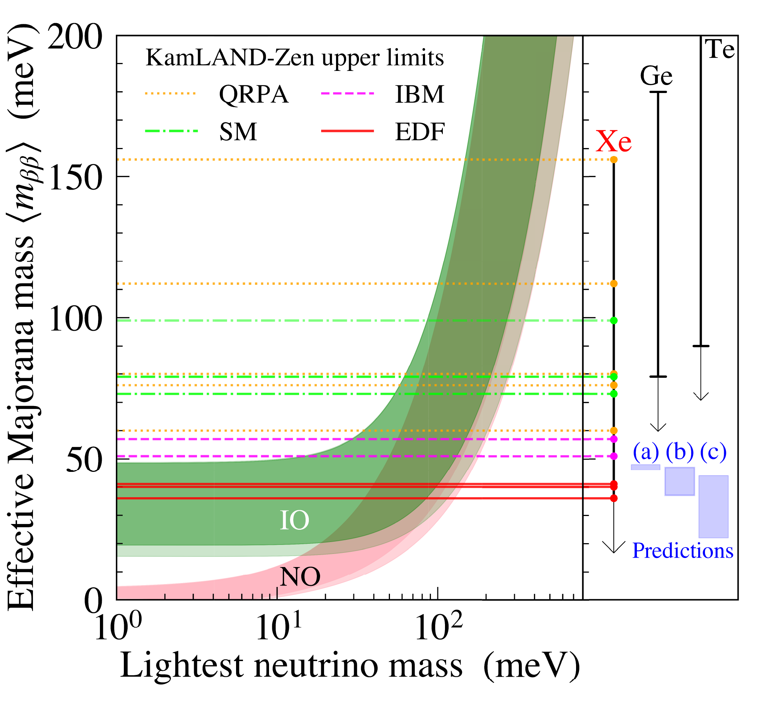

*Fig. 1.  Effective Majorana neutrino mass as a function*

*of the lightest neutrino mass*