SOURCE VELOCITY IN COLLITIONS OF 2.1 GeV PROTONS WITH GOLD TARGET

S. P. Avdeyev¹, W. Karcz¹, V. V. Kirakosyan¹, P. A. Rukoyatkin¹,
V. I. Stegaylov¹, A. S. Botvina²
¹ Joint Institute for Nuclear Research, Dubna, Russia; ² Frankfurt Institute for Advanced Studies Johann Wolfgang Goethe University, Frankfurt am Main, Germany
E-mail: avdeyev@jinr.ru

One way of evaluating the degree of equilibration in reaction, as well as determine the average source velocity, is through invariant cross section analysis as a function of longitudinal and transverse velocity.
In the present work the source characteristics of multifragmentation are investigated for the p + Au collisions at 2.1 GeV. Beam of 2.1 GeV protons were obtained from the Dubna superconducting accelerator NUCLOTRON. Invariant cross sections of carbon fragments from target spectator were measured with the 4π device FAZA [1]. Fig. 1 shows the longitudinal versus transverse velocity plot (β⊥ vs β||) along points of constant invariant cross section for carbon fragments. The lines in Fig. 1 are fits to the data for a constant value of invariant cross section in the (β⊥ vs β||) plane.

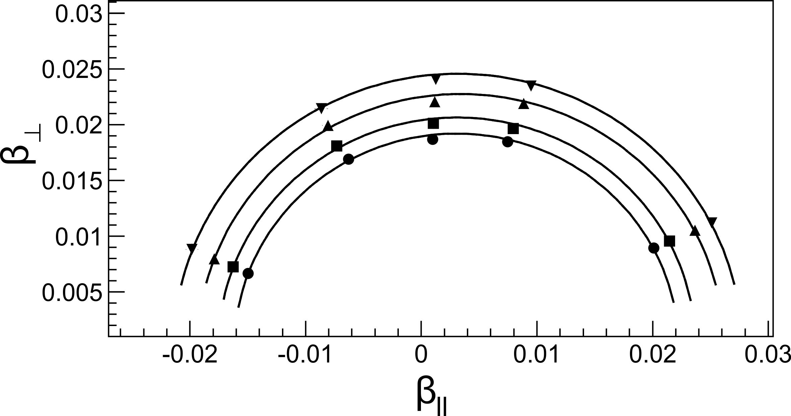
Fig. 1. Longitudinal versus transverse velocity plot along points of constant invariant cross section for carbon fragments. Points – experiment. Lines are fits to the data for a constant value of invariant cross section in the longitudinal versus transverse velocity plane.

It was found to a good approximation that the data for a given invariant cross section are isotropic; i.e., they can be described by a circle with fixed locus, corresponding to a single average source velocity. Mean source velocity (β = v/c) of target spectator is 0.0032 ± 0.0003. The research was supported by the Russian Foundation for Basic Research, Grant No. 19-02-00499.

1. V.V. Kirakosyan et al., Instr. and Exp. Techn. 51 No. 2, 159 (2008).

