**Advantages and Disadvantages of Timepix detector for SPECT/CT**

V.A. Rozhkov

*Joint institute for Nuclear Research, Dubna, Russia*

E-mail: rozhkov@jinr.ru

The report presents the advantages and disadvantages of using the Timepix family detectors [1] as a registration system for SPECT and CT scanners. The possibilities of using pixel detectors for creating multimodal SPECT/CT systems are demonstrated. The possibilities of using pixel detectors for creating multimodal SPECT/CT systems are demonstrated. Much attention is paid to microtomography systems. The perpectives for using CdTe as a sensor are considered.

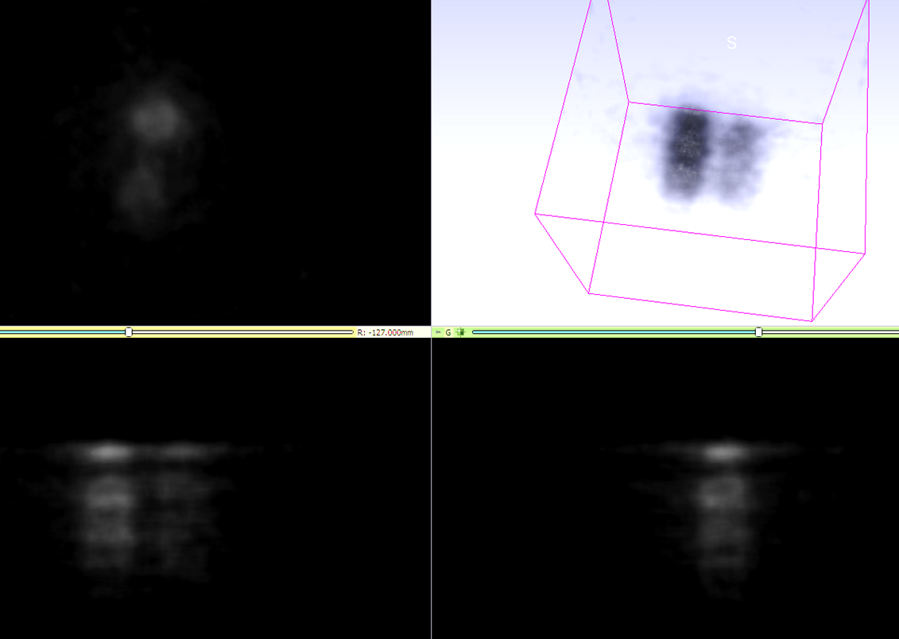

*Fig.1. SPECT phantom image with Tc-99m.*

1. R. Ballabriga. Asic developments for radiation imaging application: The medipix and timepix family / R. Ballabriga, M. Campbell, X. Llopart // Nuclear Instruments and Methods in Physics Research Section A: Accelerators, Spectrometers, Detectors and Associated Equipment. – 2018. – T. 878. – p. 10-23.