INFLUENCE OF NUCLEON PAIRS ON THE NUCLEAR SURFACE TENSION

N.G. Goncharova
Lomonosov Moscow State University, Faculty of Physics, Moscow, Russia
E-mail: n.g.goncharova@gmail.com

The calculation of the surface tension coefficients σ of even-even nuclei [1] showed the decisive role of shell effects in the formation of the value of σ. The addition of neutron pairs to the "magic" nucleus leads, as a rule, to a decrease in σ (Fig. 1). Low values ​​of σ change little upon addition of neutron pairs until a neutron-closed subshell is obtained, when the surface tension sharply increases (Fig.1a).
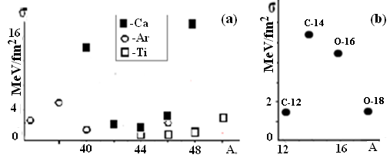
Fig.1a. Surface tension of Ca, Ar and Ti nuclei Fig.1b. Surface tension of C and O
The role of proton pairs in the formation of surface tension is more controversial. Adding a pair of protons to a closed protons shell leads to a significant decrease in σ [σ(¹⁸O)/σ(²⁰Ne)≈4.5; σ(⁴⁸Ca)/σ(⁵⁰Ti)≈5.5]. The surface tension of the nucleus, as a rule, increases if the addition of a pair of protons completes the shell to closeness [σ(⁴⁰Ca)/σ(³⁸Ar)≈3.3;], however, the addition of a pair of protons to the ¹⁴C nucleus leads to a decrease in σ (Fig. 1b), although in this case a closed proton subshell is formed. The relatively low value of σ for the ¹⁶O nucleus is the source of the formation of a complex structure of giant resonance in this nucleus, which has not been adequately explained in terms of the many-particle shell model [2,3].
The influence of the shell structure on the surface tension of heavy stable nuclei is clearly manifested in mercury and lead isotopes: the surface tension coefficient σ more than triples when a pair of protons (3s)² is added to the ²⁰⁴Hg nucleus and the "magic" number of protons 82 is formed. Completing the construction of the lead’s neutron shell up to N=126 leads to an even sharper increase in σ and the achievement of the maximum of this coefficient among all nuclei: σ(¹²⁶Pb)≈34MeV/fm².

- N.G. Goncharova, Phys. Part. Nucl. 50, 532 (2019).
- G.E. Brown, M. Bolsterly, Phys. Rev. Lett. 3, 472 (1959).
- N.G. Goncharova, Phys. At. Nucl. 85,75 (2022).

