DIFFUSENESS OF NUCLEON DENSITY DISTRIBUTION AND DOUBLE-FOLDING NUCLEUS-NUCLEUS POTENTIAL

M. V. Simonov^{1,2}, A. V. Karpov², T. Yu. Tretyakova^{1,2}
¹Lomonosov Moscow State University, Moscow, Russia;
²Joint Institute on Nuclear Research, Dubna, Russia
E-mail: simonov.mv16@physics.msu.ru

Description of the internuclear interaction is the one of the most important tasks in analysis of various nuclear reactions. In particular, the position and height of the barrier determined by Coulomb and nuclear interactions should be estimated in order to evaluate general properties of fusion of heavy nuclei.
The calculations of fusion barriers are carried out within the double-folding approach assuming the diabatic regime of collisions of heavy ions with Z, N > 9. Nucleon density distributions are required to calculate the double-folding potential [1, 2]. Thus, radial parameters of nucleon densities given in the Fermi-distribution form are approximated on the basis of rms charge radii [3]. According to experimental data [4], diffuseness parameters of nucleon distributions are not clearly correlated with Z, N, A of corresponding nucleus and have significant uncertainties. Therefore, the diffuseness values were fitted to reproduce the Bass barriers [5] for spherical nuclei (fig. 1). Potential barriers obtained in such a way can be used as estimation of fusion barriers in heavy ion reactions.

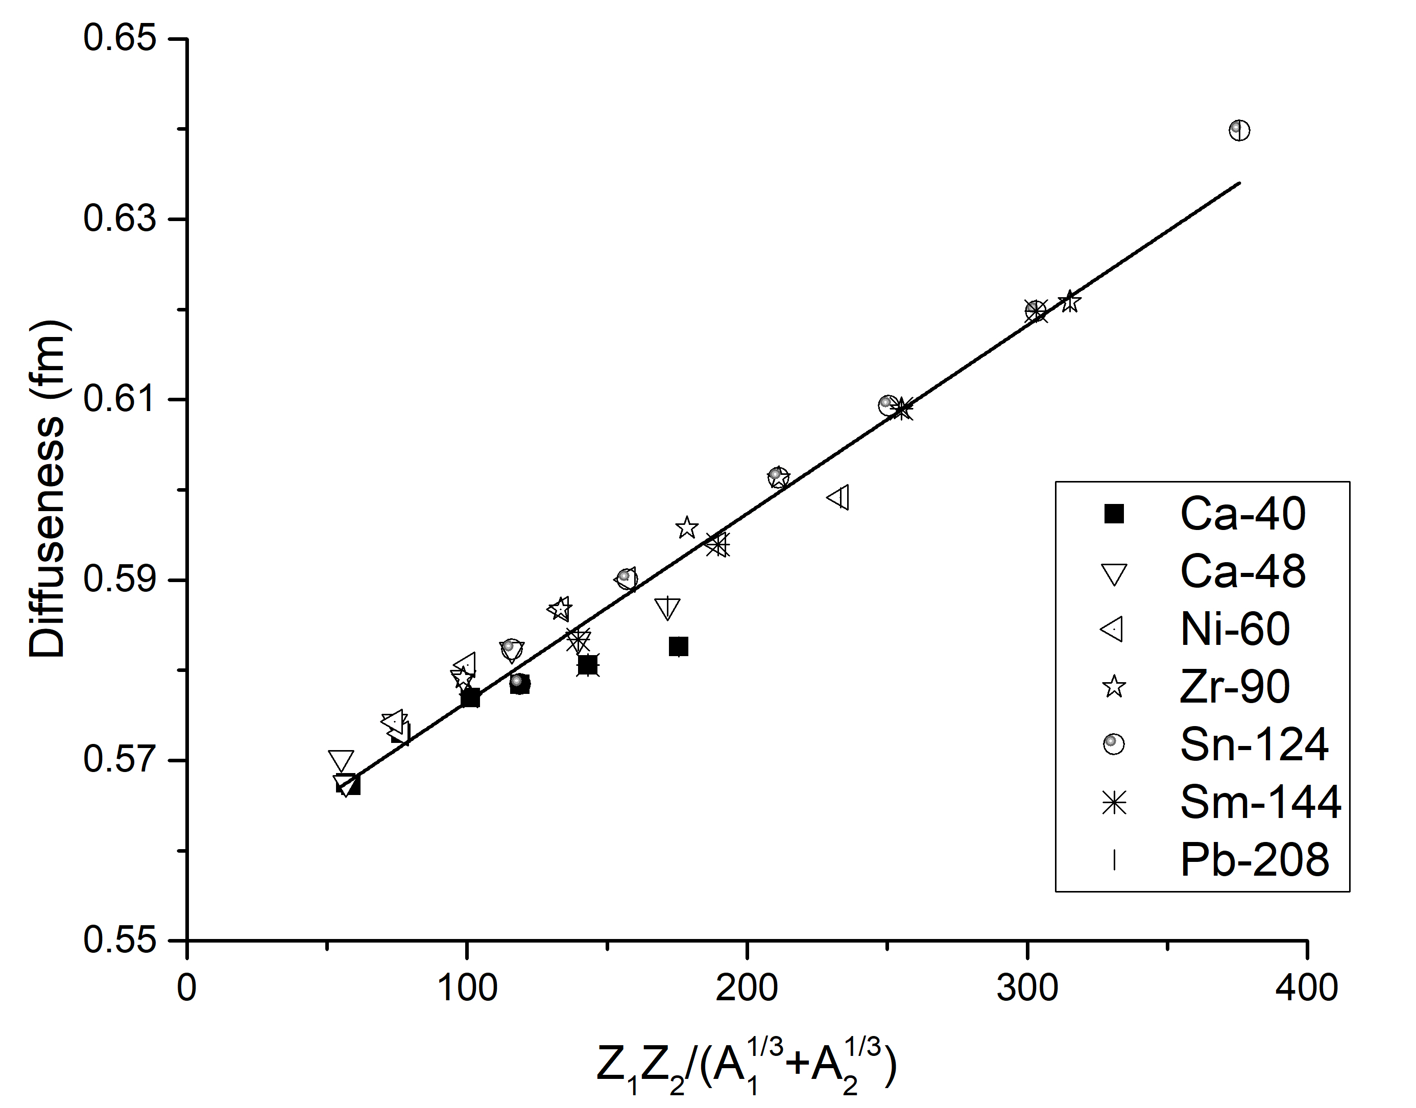
Fig. 1. Fit of the duffuseness values obtained from comparison with the Bass barrier.

- V. Zagrebaev et al. (2007). Phys. Part. Nucl., 38, 4, 469 (2007).
- M. V. Simonov, A. V. Karpov, T. Yu. Tretyakova, Proceedings of LXXI International conference “Nucleus-2021”, 307 (2021).
- I. Angeli, K. P. Marinova, At. Data Nucl. Data Tables. 99, 69 (2013).
- H. De Vries, C. W. De Jager, C. De Vries, At. Data Nucl. Data Tables. 36, 495 (1987).
- R. Bass, Phys. Rev. Lett. 39, 265, (1977).

