**DEVELOPMENT OF FAST NEUTRON THERAPY TPS**

A. N. Moiseev1,2

*1Medscan LLC, Moscow, Russia; 2NIITFA, Moscow, Russia*

E-mail: moiseev@medscannet.ru

NIITFA is participating in development of new fast neutron machine for external beam therapy. It’s based on C-arm gantry and D-T neutron generator. So overall design is very close to conventional x-ray LINACs and rises similar problems of dose calculation. Due to unavailability of commercial treatment planning systems (TPS) for fast neutron dose calculation, development of new TPS has been started recently. The TPS architecture is based on brachytherapy PlanB (RT7 LLC) system [1]. Planning tab graphical user interface can be seen on Figure 1.

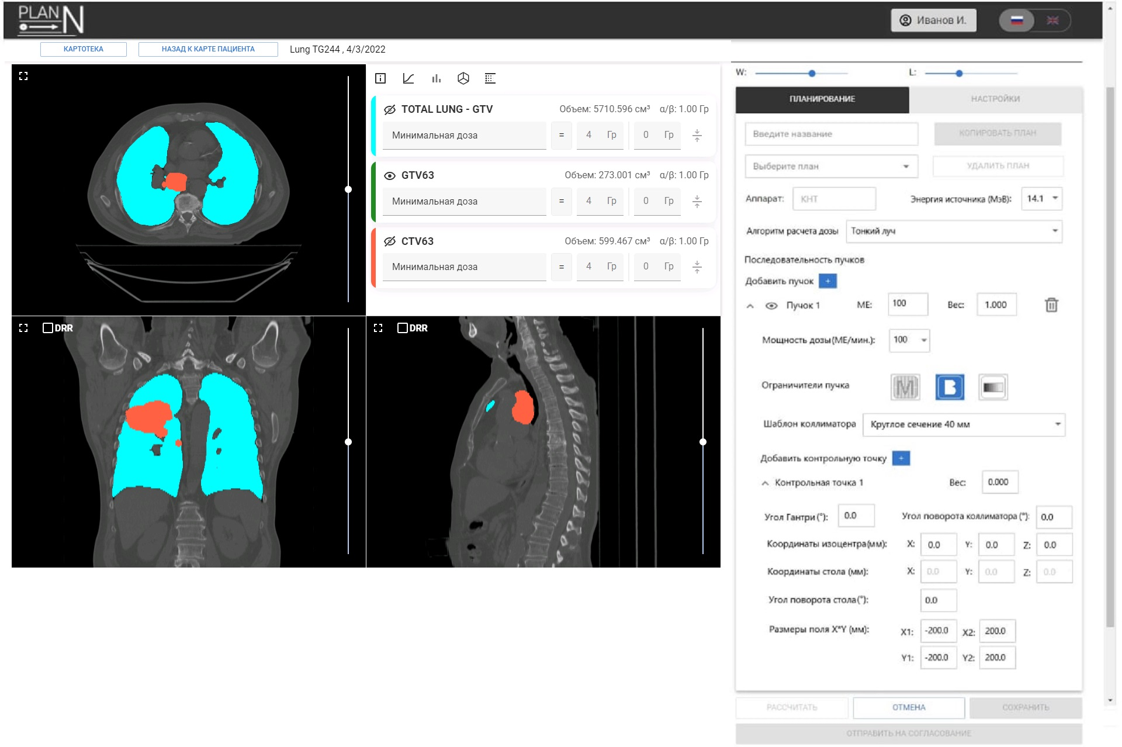

*Fig. 1. Dose planning tab in developing TPS.*

Dose calculation engine will be based on pencil beam (first step) and Monte-Carlo simulation (second step). Pencil beam algorithm is currently under implementation in system. Monte-Carlo calculations will use external general-purpose radiation transport code with dose calculation broker/pipeline, controlled by TPS server.

Developing TPS also can include numerous modern approaches for dose calculation, radiobiology models, dose optimization, etc. as it Russian-based and open for collaboration. But the main goal is clinic-ready TPS for external beam fast neutron therapy and we believe it will be available in close future.

1. Моисеев А.Н. Использование изображений разной модальности для реконструкции позиции аппликатора при брахитерапии. Трудный пациент. 2022; 20 (1): 54–57. doi: 10.224412/2074-1005-2022-8-54-57.