**THE APPROBATION OF ION-PLASMA TECHNOLOGY FOR REACTOR GRAPHITE DEACTIVATION**

A.S.Petrovskaya1,2, A.B. Tsyganov1,2, A.Yu. Kladkov3, S.V. Surov3,

D.A. Blokhin3, P.O. Gredasov4

*1 Plasma application department, InnoPlasmaTech LLC, St.Petersburg, Russia, 2 Intro-Micro LLC, St.Petersburg, Russia, 3“Science and Innovations” JSC, ROSATOM, Moscow, Russia, 4 Leningrad NPP, Rosenergoaton JSC, Electric power division of ROSATOM, Sosnovy Bor, Russia.*

E-mail: anita3425@yandex.ru

At present time a wide search of effective technology to deactivate reactor graphite is very acute due to the large volumes of accumulated irradiated graphite in the world (about 100 thousand tons) and the challenging problem of uranium-graphite reactors decommissioning period. The ion-plasma technology (IPT) for deactivation of reactor graphite has advantage compared with traditional radiochemistry in versatility (IPT works with any kind of radionuclides) and in the absence of the additional secondary liquid radioactive wastes (IPT buffer media is inert gas forming no chemical compounds with radionuclides). Our technology provides ion sputtering of irradiated reactor graphite surface in the “shortened” microplasma discharge in argon (it is wide known that the dose-forming 14С isotope is localized mainly inside of near-surface layers of reactor graphite blocks). The microplasma discharge is ignited between the reactor graphite (cathode) and the tantalum electrode collector (anode) under discharge parameters: current density (0.001 – 1) A/cm2), voltage (300-1000 V), argon pressure (0.01-1 atm.), discharge gap (1-5 mm). During reactor graphite treatment in the microplasma discharge, the graphite surface is sputtered and the sprayed carbon atoms are deposited on the anode surface. The results of SEM analysis of above microplasma exposed collector tantalum electrode surface (Fig. 1.) are concept proving and demonstrating workability of our ion-plasma technology.

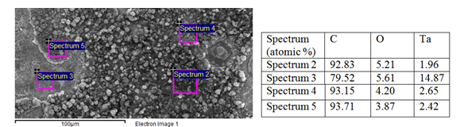

*Fig. 1. SEM image and X-ray microanalysis elemental composition of Ta anode surface.*

Technology is patented in collaboration of Intro-Micro LLC, Concern Rosenergoatom JSC and Rosatom [1] and is also suitable for Fukushima NPPs accident dismantling efforts.

1. A.S.Petrovskaya, A.B.Tsyganov, M.R.Stakhiv, Patent RU №2711292, patent pending: International patent application PCT/RU2019/000816 (14.11.2019), entering national phase: US 20210272715, EP 19888171.6, CA3105179A1, CN112655056A.