EMISSION NANOSTRUCTURE SOURCES IN MULTI-WIRE PROPORTIONAL CHAMBERS WORKING AT LHC

G. Е. Gavrilov¹, А. А. Dzyuba¹, О. Е. Maev¹, M. V. Suyasova¹, M. E. Buzoverya², I. A. Karpov², А. А. Аrkhipov², Т. А. Кonovalova³
¹National Research Center “Kurchatov institute”, PNPI, Gatchina, Russia; ²Russian Federal Nuclear Center – All-Russian Research Institute of Experimental Physics, Sarov, Russia; ³Sarov Physics and Technology Institute of the National Research Nuclear University MEPhI, Sarov, Russia
E-mail: otd4@expd.vniief.ru

The results of research of the origin of the spontaneous electron emission sources generation in multi-wire proportional chambers (MWPC) at LHCb experiment in Large Hadron Collider (LHC) [1] are presented. Formation of dotted carbon nanostructures on cathode copper foil with sp¹, sp² and sp³ hybridization of electron levels is shown up as a result of complex research by atomic-force microscopy (AFM), elemental analysis and Raman spectroscopy methods of cathode samples from MWPC demounted from facility. Carbon nanostructures presence in the area of cathode spontaneous emission currents generation is proved by effect of resistive shift in current-voltage characteristic (I-V curve) measurements by AFM methods. Moreover according to AFM morphology of the surface of these structures resembles the results of research of nanocarbon formation derived under laboratory conditions at high temperature in vacuo.
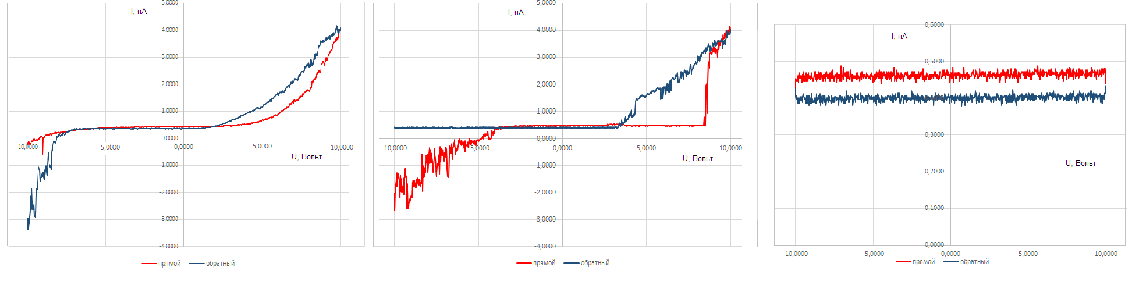
Fig.1. Standard I-V curves obtained in spontaneous electron emission area: a - bipolar hysteretic type; b – unipolar type; c – linear type.
Frenkel-Pool model [3,4] is chosen for analysis of the emission ability of the cathode formations by hysteresis I-V curve due to absence of the significant morphological defects increasing the aspect ratio on the cathode surface. According to this model electrons are emitted by electrically active impure centers in cathode carbonized layer at reaching the activation energy (Е_{о}). Estimation based on obtained I-V curves shows that Е_{о} ∼ 0.05 – 0.06 eV for MWPC cathode samples.

- F.P. Albicocco et al., Journal of Instrumentation. 14. 11031 (2019)
- A. Dzyuba, G. Gavrilov, I. Karpov, M. Buzoverya et al., Book of abstracts 71 Int. Conf. “Nucleus-2021”. 165 (2021).
- А.I. Ivanov et al., Fizika I Tekhnika Poluprovodnikov. 51. 1357 (2017).
- I.V. Kurkina et al., J. Phys. D. Appl. Phys. 49. Art.no 095303 (2016).

