**THE DOSIMETRY OF FLASH PROTON BEAMS**

I.A. Yakovlev1,2, S.V. Akulinichev1,2, Yu.K. Gavrilov1, D.A. Kokontsev1,2, V.V. Martynova1

*1Institute for nuclear research of RAS, Moscow, Troitsk, RF;*

*2 Hospital of RAS, Moscow, Troitsk, RF*

E-mail: [iv.a.yakovlev@gmail.com](mailto:iv.a.yakovlev@gmail.com)

Proton flash therapy with high dose rates is at the forefront of cancer treatment. The phenomenon of flash effect is to reduce the damage to normal cells with an extreme dose rate increase of over 40 Gy/s.

Radiobiological experiments aimed at studying this phenomenon may require a special dosimetry equipment [1].

Our work consisted of the formation system settings [2] including the spread-out Bragg peak (SOBP) localization and measuring the absolute values of the absorbed dose in the SOBP region in the water phantom PTW MP3‑P T41029.

We used PTW Advanced Markus Chamber Type 34045 ionization chambers (IC) in pair with Scanditronix IC-10 connected to a PTW MULTIDOSE electrometer for relative dosimetry.

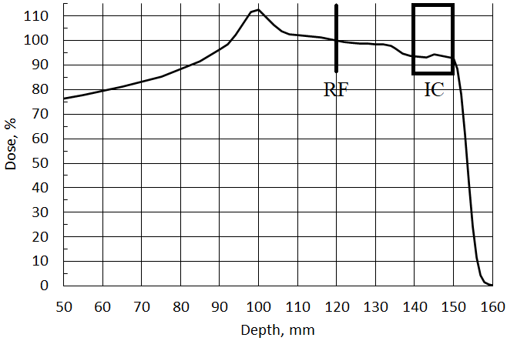

*Fig. 1. Depth dose distribution and the corresponding location of radiochromic film (RF) and Ion Camber (IC) for absolute dosimetry.*

For absolute dosimetry, we used a PTW 31010 IC and GafChromic EBT-XD films. The measured SOBP and the detectors’ location is shown in Figure 1. The result corresponds to a decrease of IC dose referred to film values by 15% in the conventional dose rate. At a dose rate above 50 Gy/s, the response of the films is an order of magnitude greater than the corresponding radiochromic film data. It indicates the impropriety of using ionization chambers in radiobiological experiments with proton beams at high and ultrahigh dose rates.

1. Desrosiers, Marc et al. “The Importance of Dosimetry Standardization in Radiobiology.” J Res Natl Inst Stan vol. 118 403-18. 30 Dec. 2013, doi:10.6028/jres.118.021

2. Akulinichev S.V., et al. Possibilities of Proton FLASH Therapy on the Accelerator at the Russian Academy of Sciences’ Institute for Nuclear Research. Bull. Russ. Acad. Sci. Phys. 84, 1325–1329 (2020).