**Generalization of theory of finite fermi-systems  
 for pygmy- and giant multipole resonances**

S. P. Kamerdzhiev1, M. I. Shitov1

*1National Research Center «Kurchatov Institute», Moscow, Russia*

E-mail: kaev@obninsk.com

The generalized equation for the main notion of the self-consistent theory of finite Fermi-systems (TFFS) [1,2] effective field ( vertex) $\tilde{V}$, which describes nuclear polarizability, has been derived for the case of consistent accounting for phonon coupling (PC) in the energy region of pygmy-and giant resonances (GDR , GMR) in magic nuclei [3,4]:

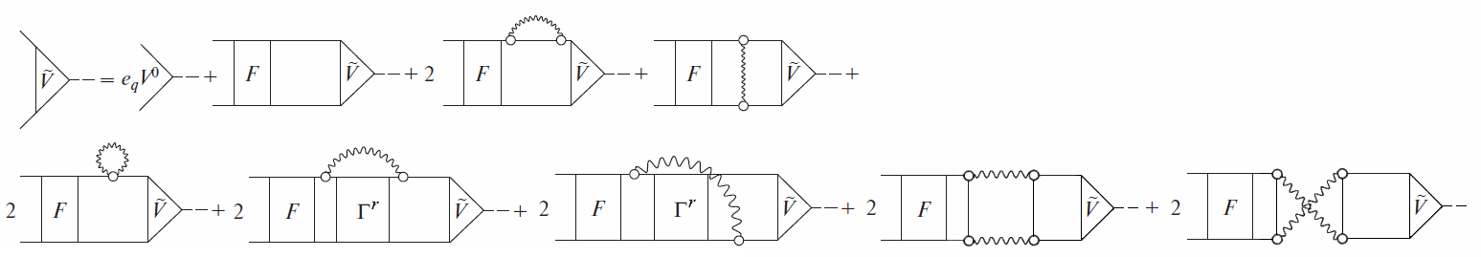

Figure 1. F – effective interaction, $Γ^{r}$– regular part of the full interaction amplitude $Γ$ [1], circles and wavy lines – phonons. The known terms are from the first to the fourth from the right, the new ones are all the others. All terms with $δ$ F are omitted.

The formulae for observable characteristics of these resonances have been obtained. New PC effects have been found and discussed: 1) numerous three-and four correlations in the ground state, 2) various induced interactions caused by the exchange of phonon, 3) (for the first time in TFFS) two-phonon configurations, 4) dynamic effects of tadpole, 5) the first and second variations of the effective interaction $δF$ in the phonon field. These effects should have many manifestations, in particular, for the description of the fine structures of PDR and GMR. Most of these effects should give a noticeable numerical contribution. Self-consistency gives a great predictive strength of the theory, which is necessary for unstable nuclei, astrophysics and nuclear data.

1.A.B. Migdal, Theory of Finite Fermi Systems and Properties of Atomic Nuclei  
(second edition), Nauka, Moscow, (1983).  
2. V.A. Khodel, E.E.Saperstein, Phys.Rep. 92, 183 (1982) .  
3. S.P.Kamerdzhiev, M.I. Shitov, EPJA , 56, 265 (2020).  
4. S.P. Kamerdzhiev, M.I. Shitov, Phys. At. Nucl. 84, 649 (2021).