Simulation of the proton beam facility at INR RAS using the TOPAS program
S. V. Akulinichev^{1,2}, G.V. Merzlikin^{1,3}, I. A. Yakovlev^{1,2}
¹Institute for Nuclear Research, Russian Academy of Sciences, Troitsk, Russia;
²Hospital of the Russian Academy of Sciences, Troitsk, Russia
³Lomonosov Moscow State University, Moscow, Russia
E-mail: merzlikin.gv16@physics.msu.ru

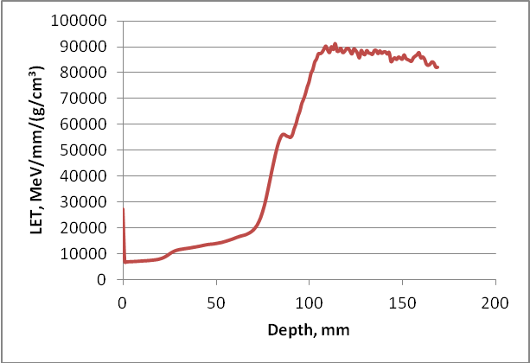  Figure. 1. Dependence of LET on depth in a water phantom. | 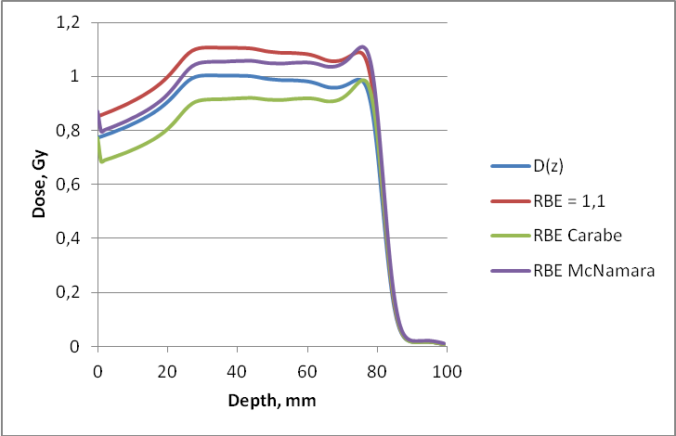  Figure 2. Biological effective dose for the HT29 cell line.
Proton therapy is currently attracting additional interest from specialists due to the possibility of using some proton accelerators in the FLASH mode with a dose rate of more than 40 Gy/s. The FLASH effect opens up new advantages for radiation therapy due to the predominant destruction of tumors. The proton beam facility at the INR of RAS makes it possible to achieve a record mean dose rate for proton accelerators, up to 10⁶ Gy/s [1]. The calculation of the characteristics of a proton beam facility in extreme conditions is a necessary step in the experiments carried out on it. As is known, the Monte Carlo method is one of the most accurate and widespread methods for calculating the interactions of radiation with matter. Previously, we compared some options for using this method [2]. In this work, the beam-forming system of the INR beam facility is modeled using the TOPAS software package. Among the features of this program, one can single out the possibility of calculating the linear energy transfer (LET), which in proton therapy affects the relative biological effectiveness (RBE) of irradiation. Examples of calculation of LET for a real modified Bragg peak (Fig.1) and effective dose for various models [3] of the dependence of RBE on LET (Fig.2) are presented and compared with the absorbed dose D(z).

- Akulinichev, S.V., et al. Possibilities of Proton FLASH Therapy on the Accelerator at the Russian Academy of Sciences’ Institute for Nuclear Research. Bull. Russ. Acad. Sci. Phys. 84, 1325–1329 (2020).
- Grigorii V. Merzlikin , Sergey V. Akulinichev, Ivan A. Yakovlev, Comparison of the results of calculations using GEANT4 and SRNA, https://doi.org/10.21175/rad.abstr.book.2021.36.5
- Paganetti et al.: TG-256 on the RBE of proton beams. Med. Phys. 46 (3), March 2019 0094-2405/2019/46(3)/e53/26.

