**Relativistic runaway electron avalanche acceleration in complex thunderstorm electric structures**

E. Stadnichuk1,2, D. Zemlianskaya1

*1Moscow institute of physics and technology, Moscow, Russia; 2 HSE University, Moscow, Russia*

E-mail: yegor.stadnichuk@phystech.edu

Thunderstorms in the Earth’s atmosphere produce short and intense gamma-ray bursts [1]. Such bursts are called Terrestrial Gamma-ray Flashes (TGF). One of possible mechanisms of thunderstorm gamma-radiation – acceleration of Relativistic Runaway Electron Avalanches (RREA) in thunderstorm electric fields [2]. Gamma-rays are produced by relativistic electrons bremsstrahlung.

RREAs are formed by secondary cosmic rays within thunderstorm media. In strong electric fields RREAs are further multiplied by positive feedback mechanisms, which can lead to self-sustainable high-energy particles generation in thunderstorms (infinite feedback) [2,3]. In complex thunderstorm electric structures RREAs are multiplied efficiently due to high-energy particles exchange (reactor feedback) between different electric regions (cells) [3].

In this research, reactor feedback by runaway electron transport between cells is studied. It is shown that runaway electron propagation between cells with its further acceleration and multiplication plays an important role in the RREA dynamics. The conditions necessary for TGF by this mechanism are derived.

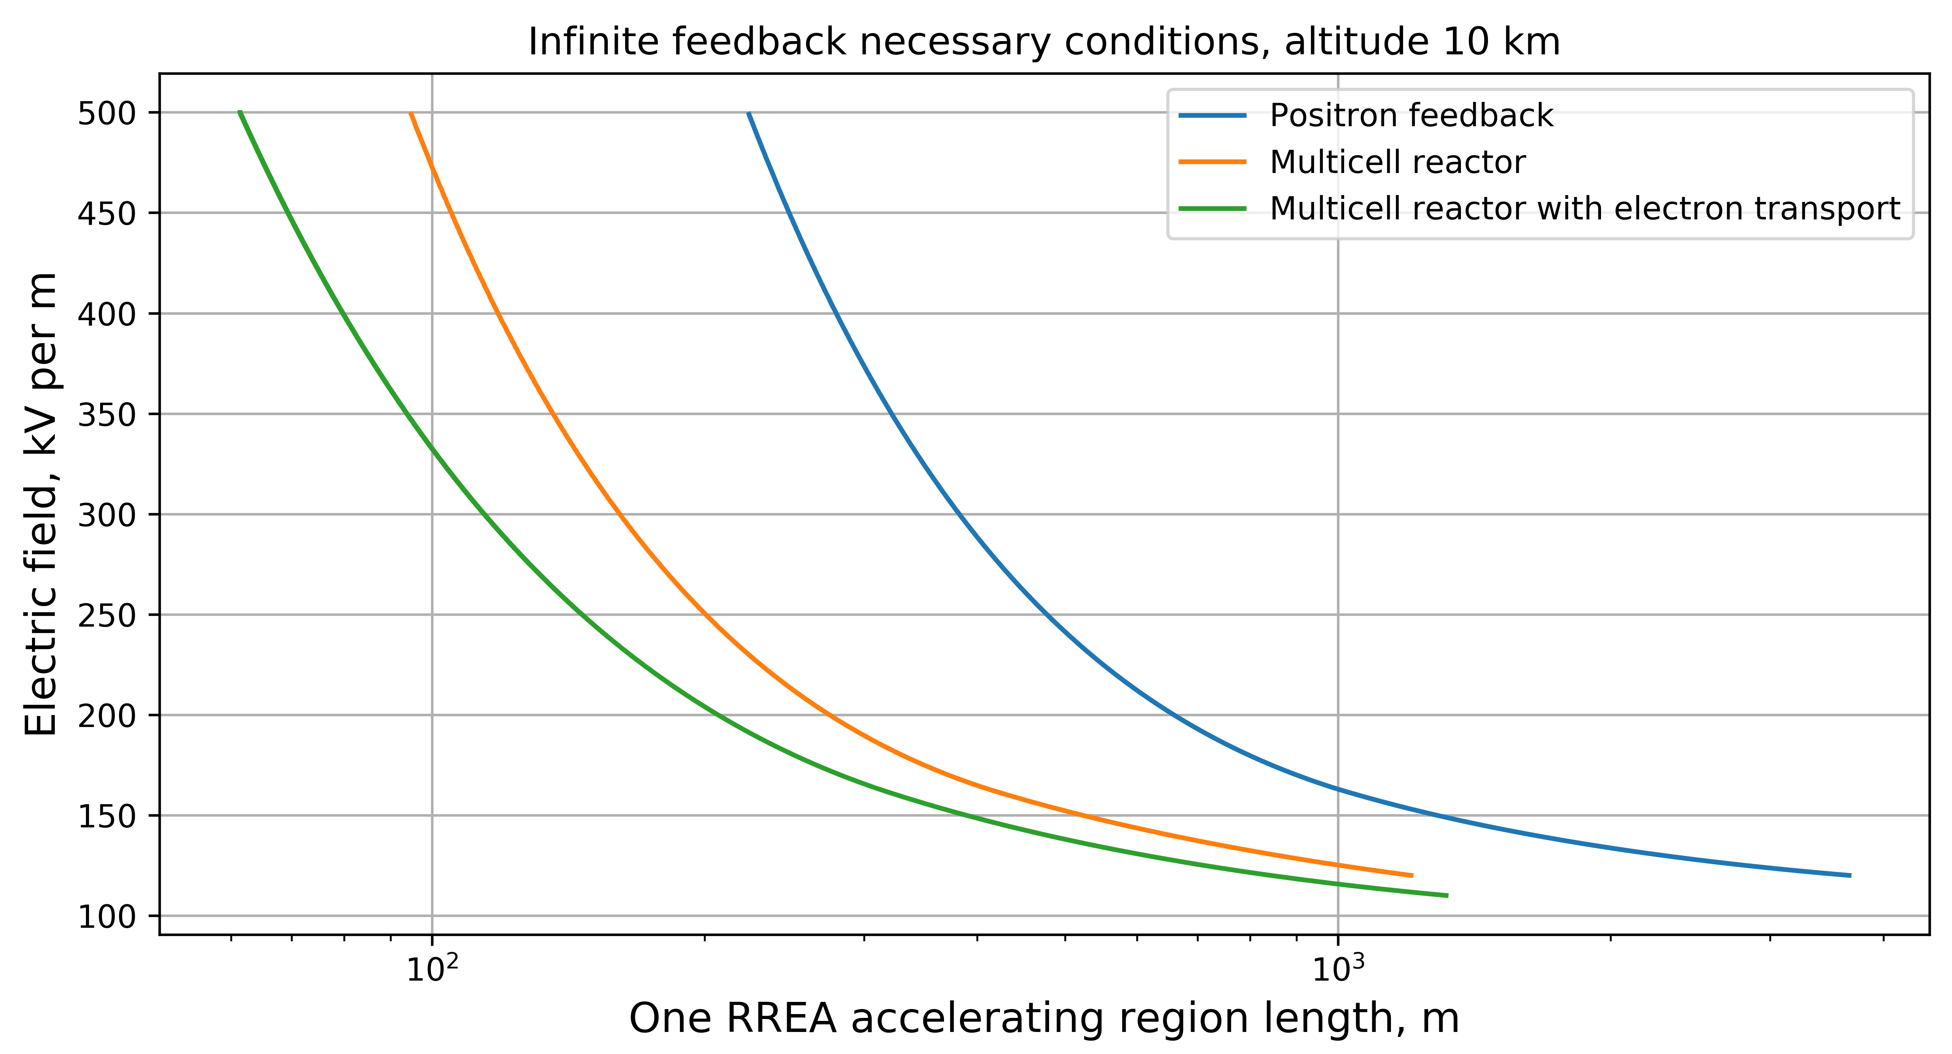

*Fig. 1. The comparison of the conditions necessary for TGF development. Blue line – TGF due to infinite positron feedback in uniform electric field, orange line –gamma-ray reactor feedback in the multicell structure. Green line – runaway electron transport between cells.*

The work was supported by a grant from the Foundation for the Development of Theoretical Physics and Mathematics "BASIS".

1. Ostgaard, N., Neubert, T., Reglero, V., Ullaland, K., Yang, S., Genov, G., . . .Alnussirat, S. (2019). First 10 months of tgf observations by asim. Journal of Geophysical Research: Atmospheres, 124 (24), 14024-14036.
2. Babich, L. P. (2020, dec). Relativistic runaway electron avalanche. Physics-Uspekhi, 63 (12), 1188{1218.
3. Stadnichuk, E., Svechnikova, E., Nozik, A., Zemlianskaya, D., Khamitov, T., Zelenyy, M., & Dolgonosov, M. (2021). Relativistic runaway electron avalanches within complex thunderstorm electric eld structures.