**Spectroscopy experiments on GABRIELA.**

**A. A. Kuznetsova*1*, A. I. Svirikhin*1*,*2*, A. V. Yeremin*1*,*2*, A. Lopez-Martens*3*, K. Hauschild*3*, A. G. Popeko*1*,*2*, O. N. Malyshev*1*, *2*, V. I. Chepigin*1*, A. V. Isaev*1*, I. N. Izosimov*1*,**  **Yu. A. Popov*1*, *2*, M. L. Chelnokov*1*, O. Dorvaux*4*, B. Gall*4* M. S. Tezekbayeva*1*, *5*,** **B.S. Sailaubekov*1, 5, 6*, N.I. Zamyatin*1,*and R. S. Mukhin1***1Joint Institute for Nuclear Research, Dubna, Moscow region, 141980 Russia. 2Dubna State University, Dubna, 141982 Russia. 3Center for Nuclear and Material Science, National Institute of Nuclear and Particle Physics, University of Paris-Sud, Orsay, 91400 France. 4National Institute of Nuclear and Particle Physics, Strasbourg University, Strasbourg, 67037 France.5Institute of Nuclear Physics, Almaty, 050032 Kazakhstan*, *6L.N. Gumilyov Eurasian National University, Nur-Sultan, Kazakhstan*.

E-mail: aakuznetsova@jinr.ru

GABRIELA [1] is a detection system installed at the focal plane of the SHELS [2-3] recoil separator for α-, β- and γ-spectroscopy of heavy and superheavy nuclei.

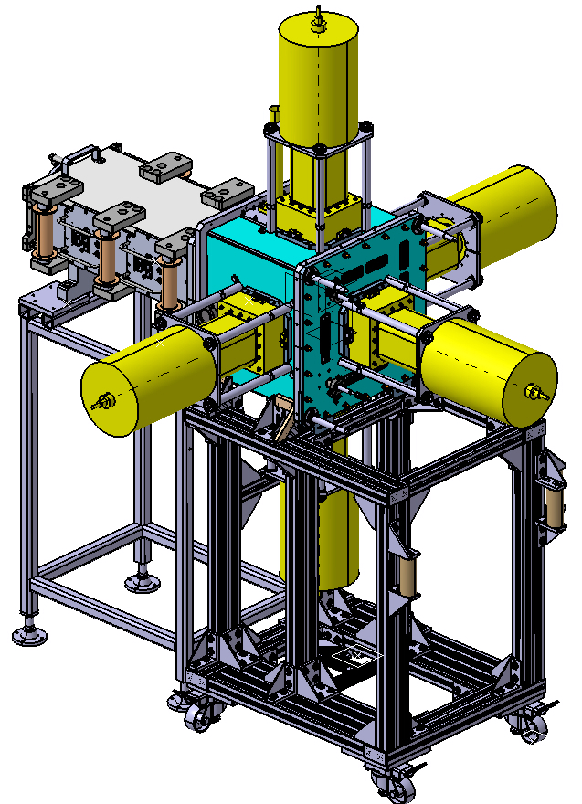In recent years experiments have been devoted to complete fusion reactions, like as 48Ca+204-208Pb [4] and 50Ti+204Pb [5], the cross sections of those reactions have the order of nanobarns. For the first time isotope of 249No was synthesized in the reaction 204Pb(48Ca,3n)249No, it has half-life 38.3±2.8 ms[6]. GABRIELA has recently been upgraded, named of GABRIELA-II (see Fig. 1. left). Instead 4 single crystals Ge-detectors were installed 5 Clover-detectors, the lets to fix gamma-quanta with best efficiency (see Fig. 1. right).

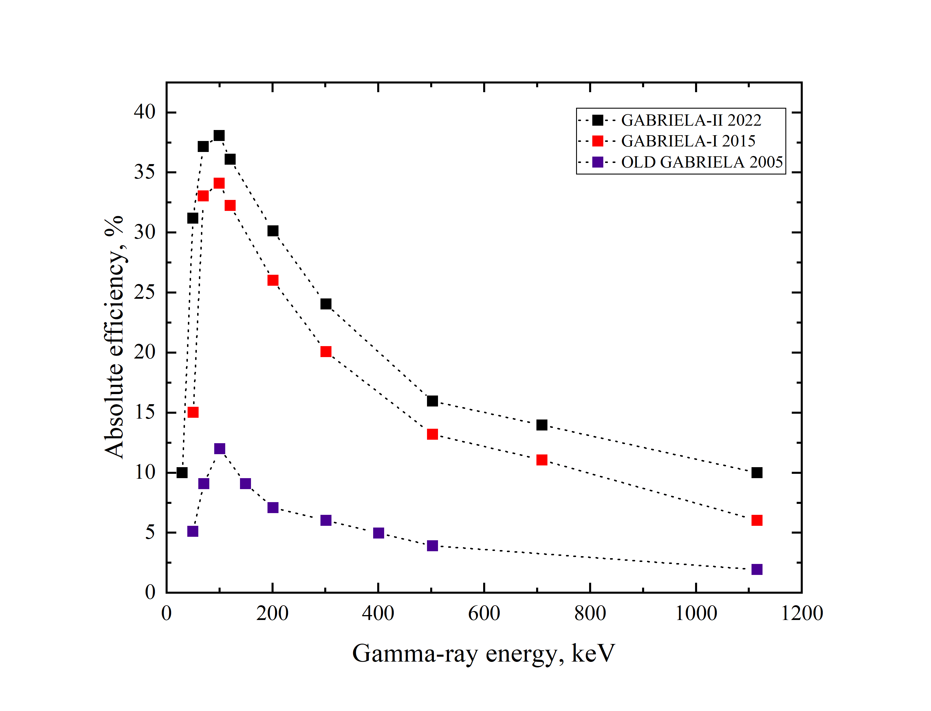

*Fig. 1. Left. GABRIELA-II; Right.Absolute efficiency registration of gamma-quanta by detector in different variation of GABRIELA.*

The first test experiment 206Pb(48Ca,2n) 252No will be carried out with GABRIELA-II setup soon.

1. K. Hauschild et al., Nucl. Instrum. Methods A 560, 388 (2006)

2. A.G. Popeko et al., Nucl. Instr. and Meth. B 376, 140 (2016)  
3. A.V. Yeremin et al., PEPAN Lett. 12, 43 (2015)

4. A.A. Kuznetsova et.al., Bulletin of the Russian Academy of Sciences: Physics, Vol. 84, No. 8, pp. 932–937 (2020)

5. A. Lopez-Martens et al., Phys. Rev. C 105, L021306 (2022)

6. M. S. Tezekbayeva et al. Eur. Phys. J. A 58:52 (2022)