**COUPLED CHANNEL METHOD WITH ASYMPTOTIC COUPLING FOR HEAVY ION NUCLEAR REACTIONS**

A.A. Gusev1,2, S.I. Vinitsky1,3, O. Chuluunbaatar1,4, R.G. Nazmitdinov1,2,

P.W. Wen*5*, C.J. Lin*6*, A. Gozdz*7*, P.M. Krassovitskiy*8*

*1Joint Institute for Nuclear Research, Dubna, Russia; 2Dubna State University, Dubna, Russia; 3Peoples' Friendship University of Russia (RUDN University), Moscow,*

*Russia; 4Institute Mathematics and Digital Technology, Mongolian Academy of Sciences,*

*Ulaanbaatar, Mongolia; 5China Institute of Atomic Energy, Beijing, China;*

*6Guangxi Normal University, Guangxi, China; 7University of M. Curie-Skłodowska, Lublin, Poland; 8Institute of Nuclear Physics, Almaty, Kazakhstan*

E-mail: vinitsky2016@gmail.com,vinitsky@theor.jinr.ru

We have applied the new version of coupled channel method with asymptotic coupling of the exit channels to the computation fusion cross sections and the astrophysical S-factor of sub-barrier and above-barrier reactions to study the deep sub-barrier fusion hindrance phenomenon in [1, 2]. It applied also to study fusion reaction 40Ca+208Pb, leading to the formation of the transfermium nucleus 248No [3]. The results obtained using modified KANTBP 3.1 code [4] and the modified Numerov method in the CCFULL code [5] were compared. For example, see fusion cross sections 64Ni+100Mo and 36S+48Ca in figures.

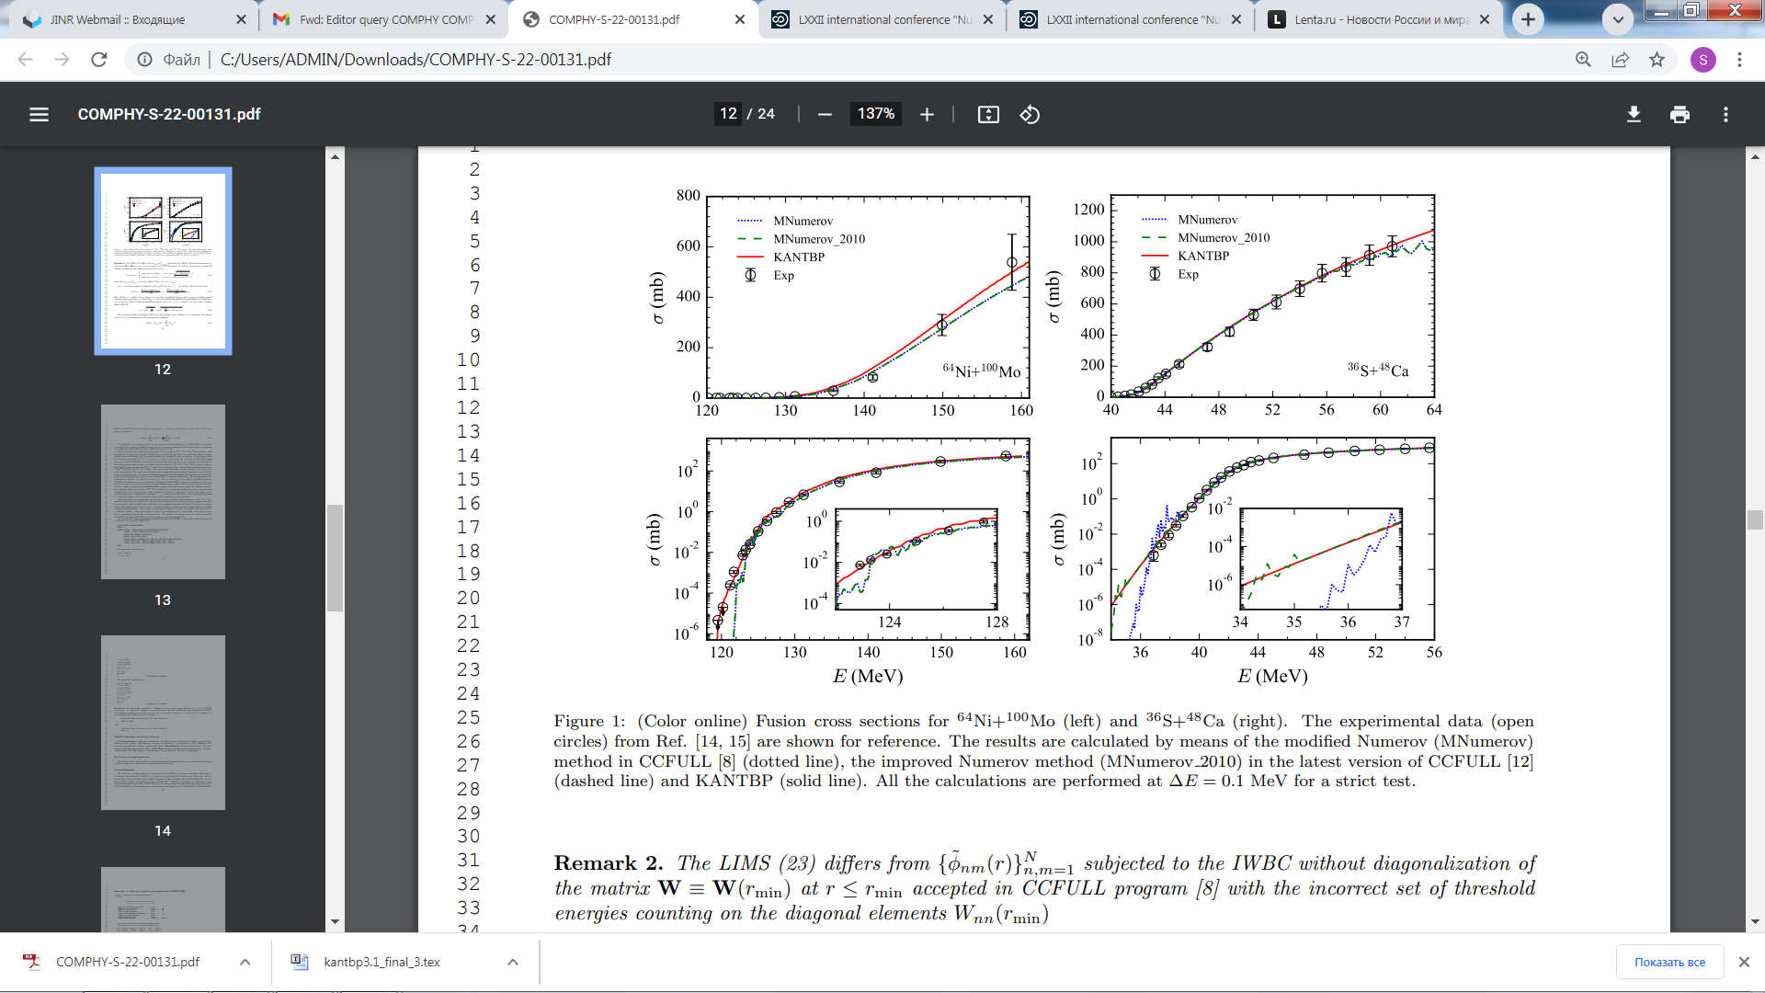

1. P.W. Wen, O. Chuluunbaatar, A.A. Gusev, R.G. Nazmitdinov, A.K. Nasirov, S.I. Vinitsky, C.J. Lin, and H.M. Jia, Phys. Rev. C 101, 014618 (2020).

2. P.W. Wen, C.J. Lin, R.G. Nazmitdinov, S.I. Vinitsky, O. Chuluunbaatar, A.A. Gusev, A.K. Nasirov, H.M. Jia, A. Gozdz, Phys. Rev. C 103, 054601 (2021).

3. E.M. Kozulin, G.N. Knyazheva, A.A. Bogachev, V.V. Saiko, A.V. Karpov, I.M. Itkis, K.V. Novikov, Y.S. Mukhamejanov, et al, Phys. Rev. C 105, 024617 (2022).

4. A.A. Gusev, O. Chuluunbaatar, S.I. Vinitsky and A.G. Abrashkevich, Comput. Phys. Commun. 185, pp. 3341–3343 (2014).

5. K. Hagino, N. Rowley, A.T. Kruppa, Comput. Phys. Commun. 123, 143 (1999).