PECULIARITIES OF THE ENERGY SPECTRUM
OF THE ¹²C NUCLEUS IN A 3α MODEL

E. M. Tursunov¹, I. Mazumdar², M. M. Begijonov¹
¹Institute of Nuclear Physics, Uzbekistan Academy of Sciences, 100214, Ulugbek, Tashkent, Uzbekistan; ²Dept. of Nuclear & Atomic Physics, Tata Institute of Fundamental Research, Mumbai 400 005, India.
E-mail: tursune@inp.uz

The aim of present work is to study peculiar properties of the ¹²C(0⁺) and ¹²C(2⁺) energy spectrum associated with removal of Pauli forbidden states from the 3α functional space. A deep αα-potential of BFW [1] will be employed which has two Pauli forbidden states in the S wave and a single forbidden state in the D wave. A variational method on symmetrized Gaussian basis is employed. For the elimination of the 3α Pauli forbidden states we use the same direct orthogonalization method from [2]. As a possible origin of non-analytical behavior of the ¹²C spectrum, consequences of the quantum phase transition (QPT) in the ¹²C nucleus will be discussed.
The direct orthogonalization method [2] is based on the separation of the complete Hilbert functional space into two parts. The first subspace L_{Q}, which we call allowed subspace, is defined by the kernel of the complete three-body projector $\hat{P}.$The rest subspace L_{P} contains 3α states forbidden by the Pauli principle. After the separation of the complete Hilbert functional space of 3α states into the L_{Q} and L_{P} subspaces, at next step we solve the three-body Schrödinger equation in L_{Q}.
In Fig.1 we display the calculated lowest 0⁺ spectrum of the ¹²C nucleus as a function of ϵ, the maximal allowed eigen value of the Pauli projection operator.
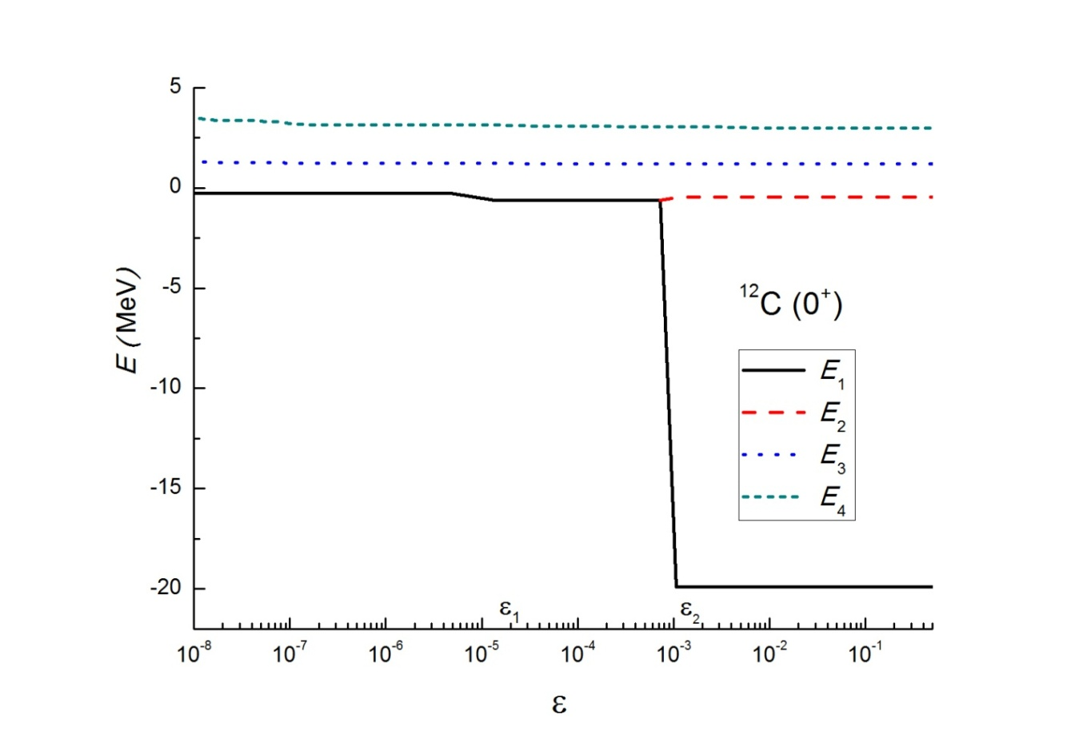
Fig. 1. - Energy spectrum of ¹²C(0⁺) as a function of ϵ.

As can be seen from the figure, there exist a special eigen value of the projector $\hat{P}$, which play a decisive role for the 0⁺ energy spectrum of the ¹²C nucleus. The corresponding eigen state of $\hat{P}$ creates a ground state of ¹²C in a deep phase, while from the left side of this point the lowest energy is close to the energy of the Hoyle state. The situation in the 2⁺ spectrum is similar.

1. B. Buck, H. Friedrich, and C. Wheatley, Nucl. Phys.A 275, 246 (1977).
2. H. Matsumura, M. Orabi, Y. Suzuki, and Y. Fujiwara, Nucl. Phys. A 776, 1 (2006).

