**TIME-DEPENDENT DESCRIPTION OF THE REACTION 28Si(11Be,10Be) AT LOW ENERGIES**

А. K. Azhibekov1,2, V. V. Samarin1,3, M. A. Naumenko1

*1Joint Institute for Nuclear Research, Dubna, Russia; 2Korkyt Ata Kyzylorda University, Kyzylorda, Kazakhstan;3Dubna State University, Dubna, Russia.*

E-mail: azhibekoaidos@gmail.com

The evolution of the probability density of the outer weakly bound neutron of the 11Be nucleus (Fig. 1) in collision with the 28Si nucleus is described based on numerical solution of the time-dependent Schrödinger equation [1, 2]. The probabilities of outer neutron removal due to the processes of neutron transfer and nuclear breakup are determined. The results of calculating the cross sections for removal of the outer neutron from the 11Be nucleus are close to the experimental data [3]. Numerical solution of the time-dependent Schrödinger equation taking into account spin-orbit interaction [4−6] makes it possible to study the dynamics of removal of the outer weakly bound neutron of the 11Be nucleus and to determine the contributions of the neutron transfer channels and nuclear breakup in low-energy collisions with a target nucleus.

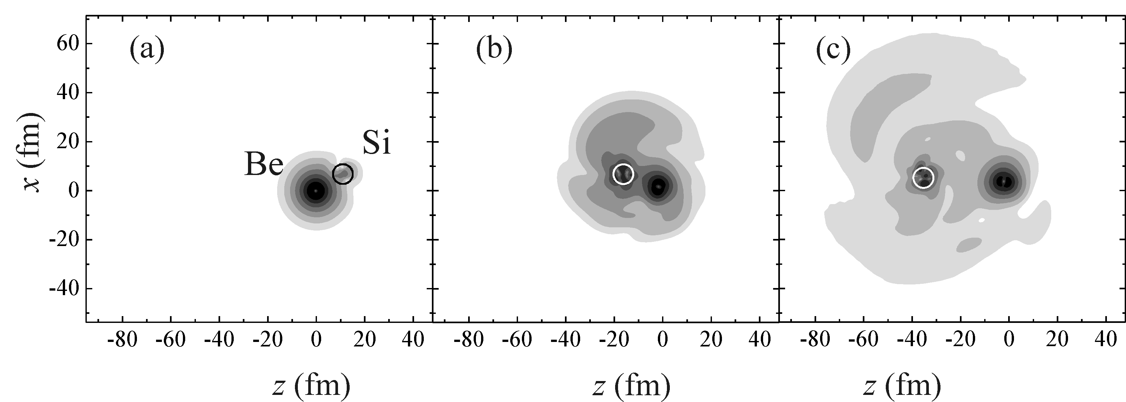

*Fig. 1. Evolution of the probability density for the outer neutron of the 11Be nucleus in the collision 11Be + 28Si at beam energy 55 MeV* *in the reference frame moving relative to the laboratory frame with a constant velocity equal to the velocity of the projectile nucleus at a sufficiently large distance from the target nucleus. The course of time corresponds to the direction from left to right.*

1. A.K. Azhibekov, V.V. Samarin, and K.A. Kuterbekov, Chin. J. Phys. 65, 292 (2020).

2. A.K. Azhibekov *et al*., Phys. Atom. Nucl. 84, 635 (2021).

3. F. Negoita *et al*., Phys. Rev. C 59, 2082 (1999).

4. V.V. Samarin, Phys. Atom. Nucl. 78, 128 (2015).

5. Yu.E. Penionzhkevich, Yu.G. Sobolev, V.V. Samarin *et al*., Phys. Rev. C 99, 014609 (2019).

6. V.V. Samarin, Bull. Russ. Acad. Sci.: Phys. 84, 990 (2020).